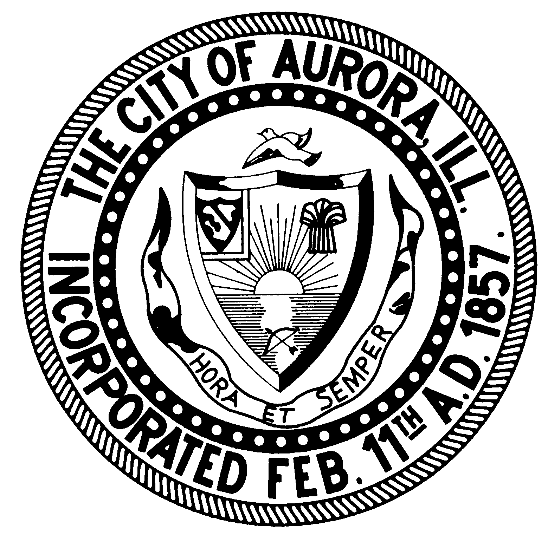

City of Aurora

Aurora Public Art

20 East Downer Place, 3rd Floor, Aurora, Illinois 60505

Email: EvansJ@aurora.il.us

www.aurora-il.org/329/Public-Art-Commission/

Jenn Byrne Evans

Public Art Director

FOR IMMEDIATE RELEASE 1-11-2022
FOR MORE INFO CONTACT:
Jenn Byrne Evans
EvansJ@aurora.il.us

Aurora Public Art: 30 New Murals in 2021, More to Come in 2022

Between August 1st and December 31st, Aurora Public Art installed 30 new murals in Downtown Aurora: 3 murals that are at least 40’ in size, 4 temporary murals designed to host augmented reality, 6 utility box murals, and Aurora’s first street art gallery with work by 17 artists. Public Art Director Jenn Byrne states, “We are so excited to bring this much color and community expression to Downtown Aurora in one season.” Aurora Public Art would like to thank their sponsors: Aurora Downtown, the National Endowment for the Arts, the Burlington Northern Foundation, BUSH Construction, Sunbelt Rentals, and the City of Aurora.

When asked if she had a favorite project, Byrne says she had three favorite moments this season. In the Spring, while working with the team of artists on the Alebrijes mural, she learned that the parents of one of the artists, Laura Reyes, came from Oaxaca, Mexico where alebrijes are traditionally made. “I was delighted to hear that Laura’s mom was telling the artists which animals they must include. This touching moment was shared with love and laughter, and it assured me that the right artists had been selected for the job — even more than I’d realized.” Alebrijes are folk art sculptures representing animals and imaginary creatures, usually carved from wood and painted in bright colors and patterns.

Over the summer, Byrne was most proud of the graffiti wall process. “This is the first time that public art has been allowed in Aurora without design pre-approval. Street Art is like improv — it’s spontaneous; it’s not the same artform as a formal mural.” In August 2021, 17 street artists and 5 DJs came out to Lot H (SE New York St. and Lake St.) for the first annual permanent street art installation in Aurora. “The street artists’ sense of community, and the joy of actually feeling respected and appreciated by the City for their art and culture was so palpable.” The current paintings will be up for one year, and the same walls will be repainted annually.

At the end of the busy mural season, Byrne was re-energized by feedback from one particular young resident. The Diversity in Technology mural is located at 105 E. Galena Blvd., home to the APS Training Company, whose mission is “To empower vulnerable communities in Aurora by providing free and low-cost education and vocational opportunities in STEM.” And it was one of their students that was particularly vocal about how good it made her feel to see this portrait that looked like her, and she shared it on her social media, “Look at the graffiti graphics on the building where I work. Girls in tech…YES #girlboss #techjobs.”

In 2022, Aurora Public Art looks forward to installing 4 more murals, 18 street art paintings, and activating 4 murals recently installed through augmented reality (i.e., adding 3D animation elements which will be available through a free phone app). We are also thrilled to share that we’ll be initiating new programs for sculpture as well as Public Art in the neighborhoods.

E-Blast Sign-Up: http://bit.ly/APAC_mailing_lists
Website: www.aurora-il.org/329/Public-Art-Commission
Facebook: www.facebook.com/aurorapublicart
Instagram: https://www.instagram.com/aurorapublicart/
TikTok: https://www.tiktok.com/@aurorapublicart
YouTube: https://bit.ly/APACYouTube
View Aurora Artist Portfolios: http://bit.ly/aurora_artists
Aurora Artist Portfolio Sign-Up: https://bit.ly/artist_form

Donations are always appreciated and are used to pay fair wages to artists for their services: www.communityfoundationfrv.org/profile/aurora-art-fund
Photo Credit Jenn Byrne unless otherwise indicated.
Full size photo files and in-progress photos available upon request.

Diversity in Technology
Artist: Rafael Blanco, Aurora
Address: 105 E Galena Blvd.
This mural represents female minorities in the tech industry. The second phase of the mural will be the addition of augmented reality, viewed through a free phone app, showing additional women from different backgrounds as well as animation of the green symbols behind the portrait. When published, the augmented reality will accessible through signage next to the mural.

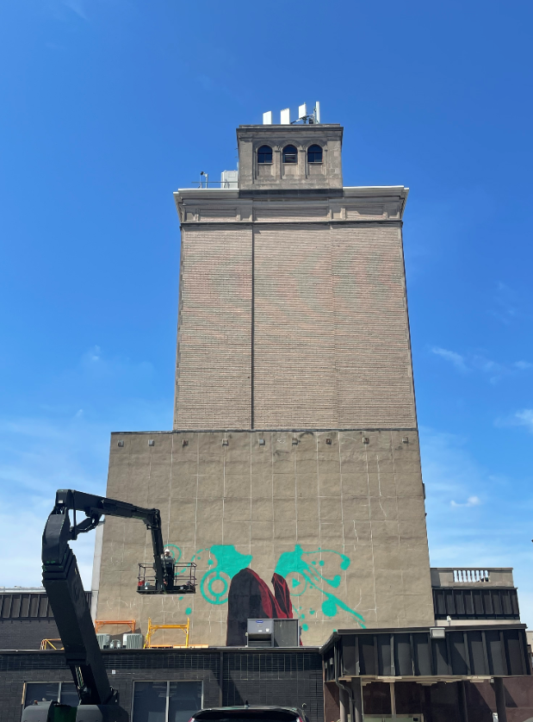 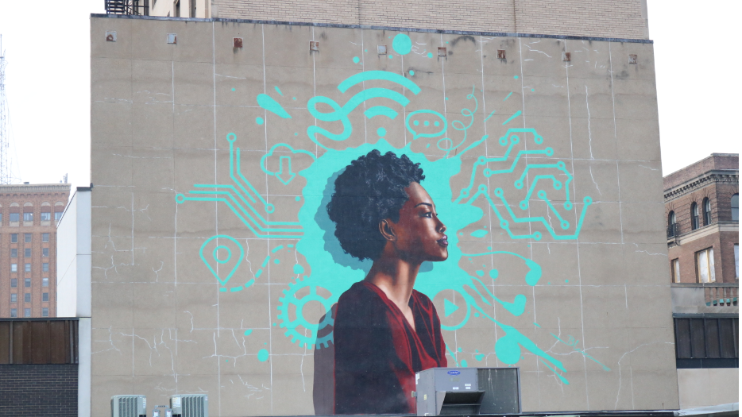
Alebrijes:
Artists:
Pierre Lucero, Aurora
Catalina Diaz, Aurora
Laura Reyes, Aurora
Janice Rodriguez, Aurora
Address: E New York St. under the BNSF viaduct

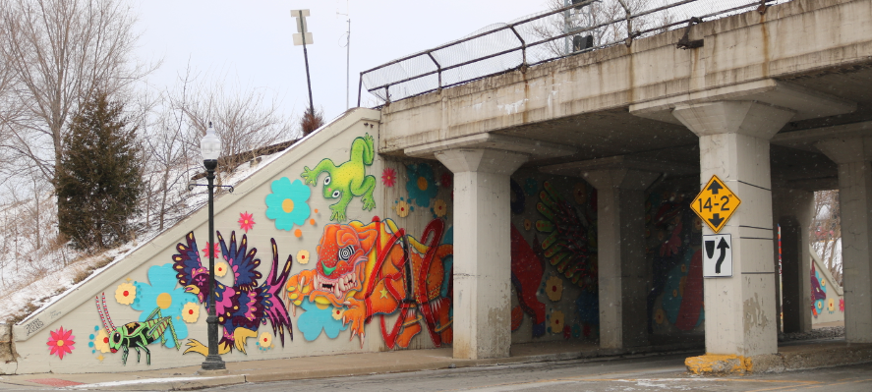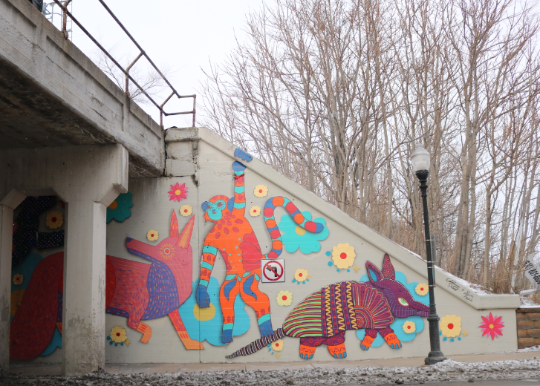

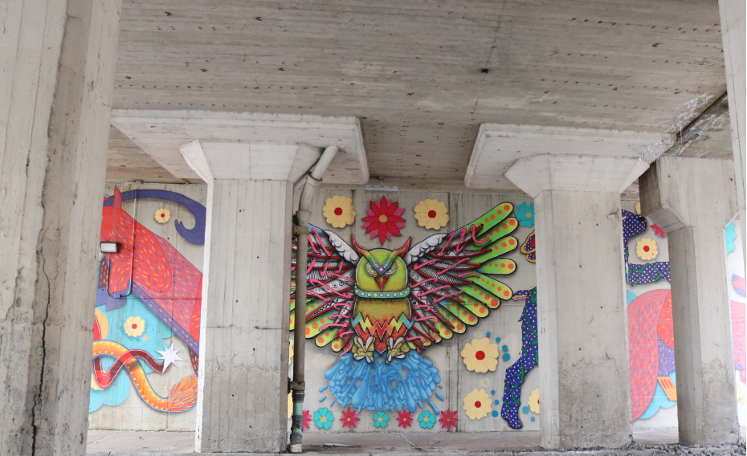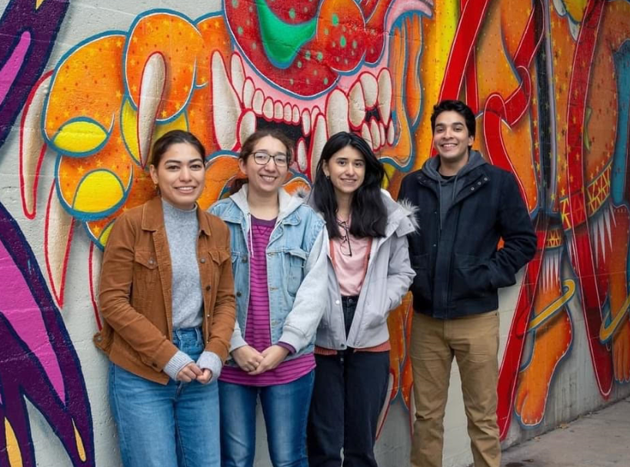
Photo: Janice Rodriguez

Alexa:
Artist: Judith “JDL” de Leeuew, Amsterdam, Netherlands
Address: 13 S. Broadway Ave.
Applicable to Aurora’s community, this design references the strength of people with disabilities and the observation that it is often those who have the least that are the most generous. The figure represents the artist’s friend Alexa, who despite suffering from Multiple Sclerosis and associated financial and social challenges, prioritizes serving others.

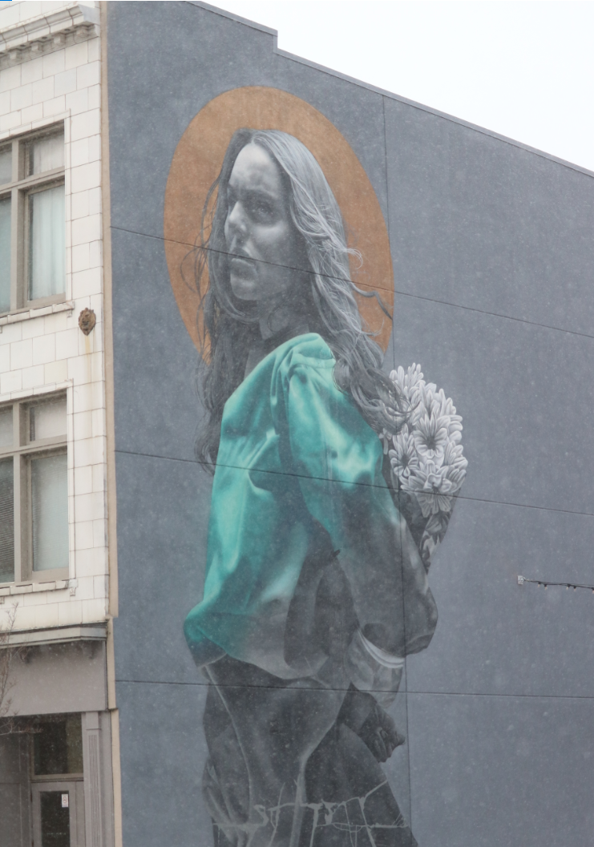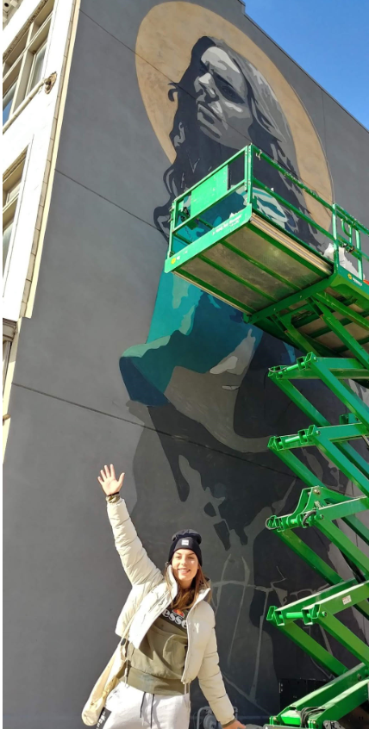

Cultural Heritage Postage Stamps: Brazil, Greece, Kenya, Luxembourg
Artist: Midwest Immersive
Augmented reality will be available in Spring 2022; 3D animation will be viewable on each banner, seen
through a free phone app. When published, the augmented reality will be accessible through signage next to the murals. The designs are based on vintage stamps from a few countries of origin of Aurora residents. The banners will be up for two years, to be renewed biannually with designs honoring some of the other countries of origin of our Aurora residents.
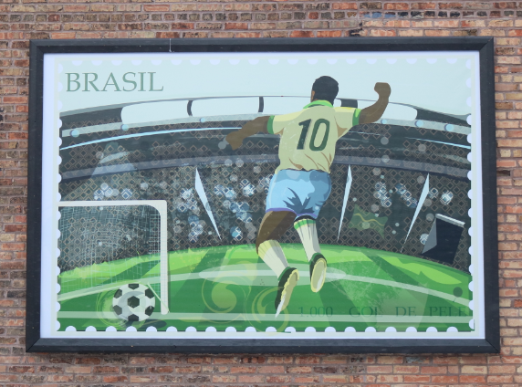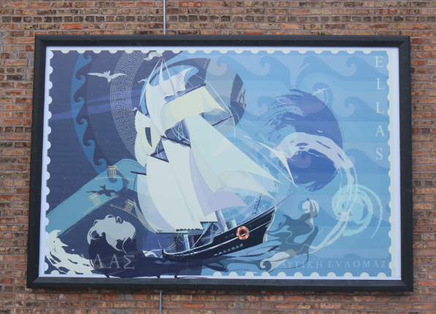

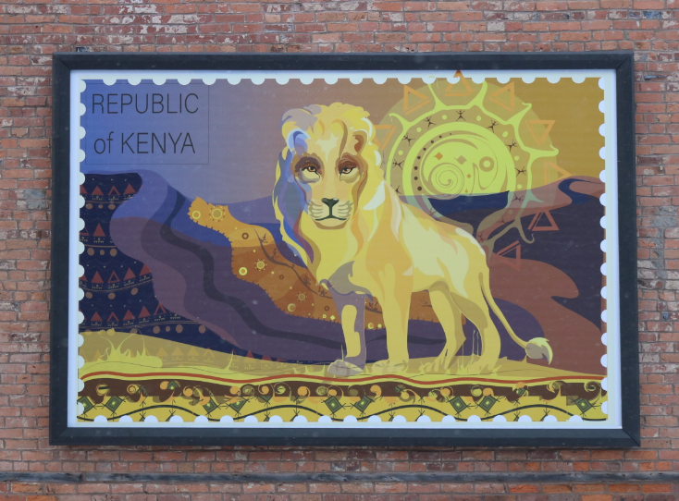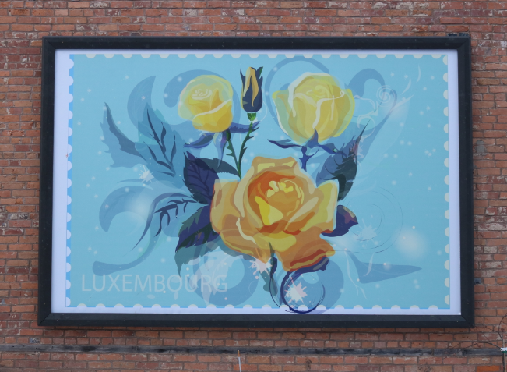

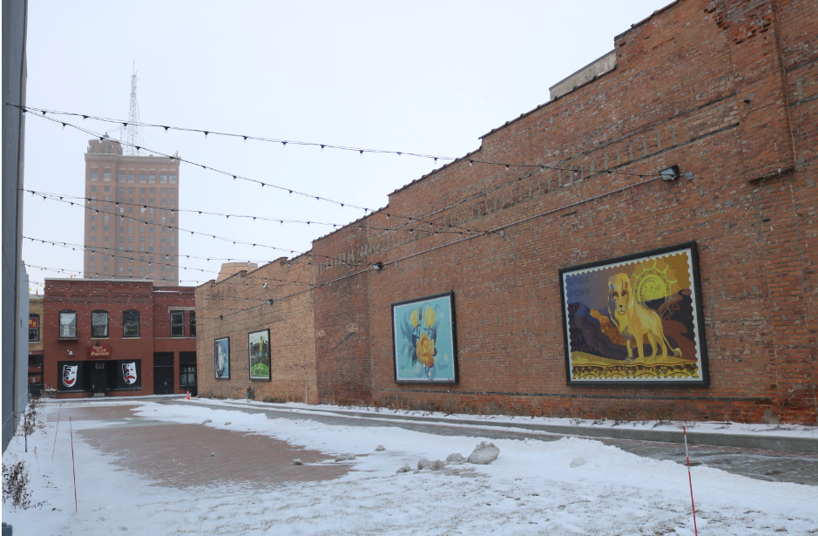

Utility Box Mural
Artist: Thuy-An Nguyen, Aurora
Location: SW River St. & Galena Blvd.
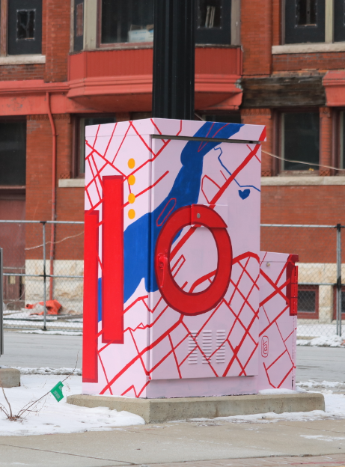

Utility Box Mural
Artist: Raul Rodea, Aurora
Location: SE River St. and Benton Ave.
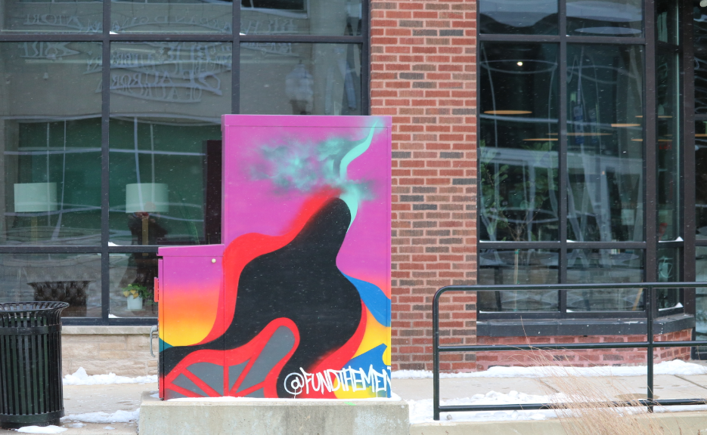

Utility Box Mural
Artist: Ali Cantarella, Chicago
Location: SW E New York & BNSF viaduct
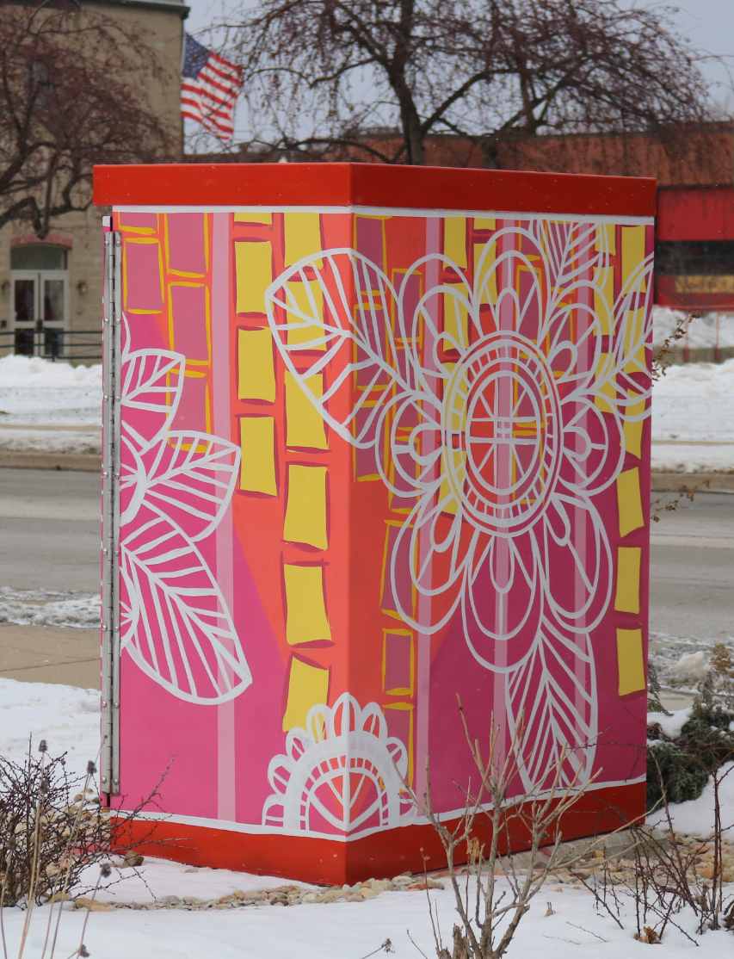

Utility Box Mural
Artist: Joshua Schultz, Oswego
Location: SE E New York St. & Broadway Ave.
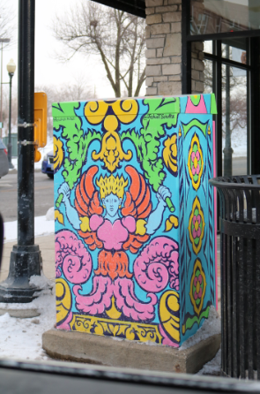

Utility Box Mural
Artist: Teresa Fiehn Millies, Aurora
Location: SW River St. & Benton Ave.
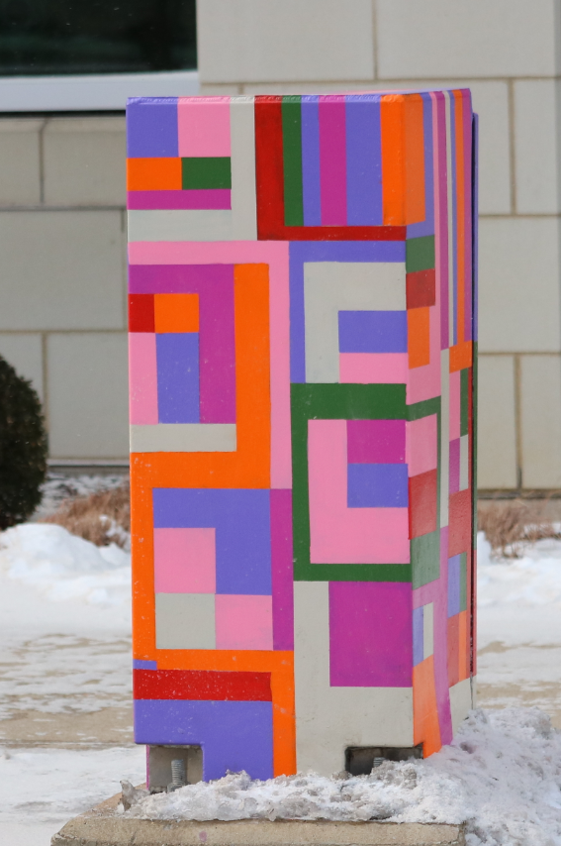

Utility Box Mural
Artist: Elizabeth French, Aurora
Location: River St. at Lot C, between Benton Ave. and Downer Pl.
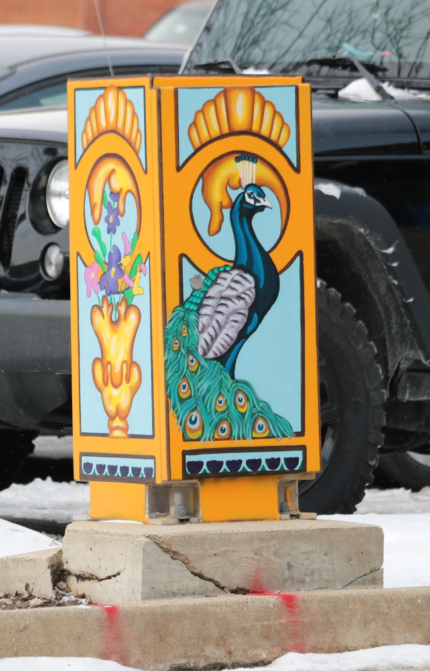

Graffiti Wall:
Co-curated by Sam “Rogue1” Cervantes, Aurora
Location: 14 Middle Ave., Lot H
