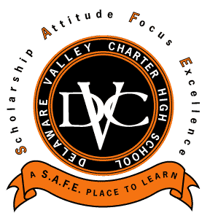

Delaware Valley Charter High School

A…. S.A.F.E. Place To Learn
5201 Old York Road
Logan Plaza- Suite A
Philadelphia, PA 19141
(215) 455-2550 Office (215) 455-5701 Fax

January 20, 2014

Delaware Valley Charter High School Family,

It is with a heavy heart that we have to confirm that on Friday, January 17, 2014, two students were wounded by gunfire in the school’s gymnasium. We know that in a world of increased violence, occurrences such as these have been in the public consciousness. However, it is very disconcerting to have it happen in our own community. While saddened by these series of events, the administration and board are even more committed to providing a safe and quality learning environment for the school's students and staff.
The administration and board know that many questions have arisen as a result of this unfortunate incident and are sensitive to the concerns of parents, students, and staff. Due to the ongoing police investigation, we are limited with the information that we can provide at this time. However, as information becomes available for the public, it will be shared with the Delaware Valley Charter High School community. We ask for your understanding and patience in this regard.
Most importantly, the administration has made it a priority to make sure parents, students, and staff are aware that diligent work has gone into ensuring that Delaware Valley Charter High School will be safer than ever. We have reviewed all security systems, processes, and procedures and heightened all of them to make certain our students and staff are safe.
Because continuity is important, Delaware Valley Charter High School will be open and operating on a regular schedule on Tuesday, January 21st. Because of tightened security measures, students are reminded to arrive at 7:30 AM to allow enough time for thorough processing and safe entry into the building. Upon arrival to school, counselors will be available for students and staff to discuss the incident. These services will be available on an ongoing basis as the need dictates. Additionally, all safety measures will be reviewed with all students and staff.
In addition to a thorough review of measures within the school to protect students and staff, the administration and board will continue to be in full cooperation with the Philadelphia Police Department as its investigation continues. Parents, we appreciate your support and understanding during this challenging time. Please know that Delaware Valley Charter High School will do all that it can to ensure a safe and positive environment for its students, your children, and its staff. We will continue to update you as the situation progresses.

Sincerely,

The Administrative Staff of Delaware Valley Charter High School

