The Affects of
John Fitzgerald Kennedy’s Presidency
On Today’s Society
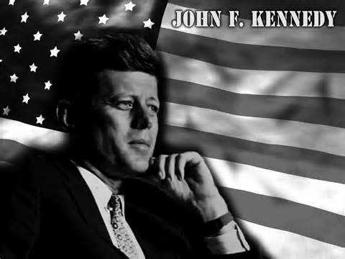
Presented By:
Teriana Ward
8th Grade Student
Kennedy-Curry Middle School

John Fitzgerald Kennedy was a brilliant man groomed for eminence. He was an excellent scholar; he earned the Purple Heart for Bravery, and went on to become the 35th president of the United States of America. JFK’s presidency touched the lives of millions and helped to procure the opportunities that we have today. His voice provided an optimistic outlook and helped to form a reality of the dream many had for a better tomorrow.

President Kennedy created the Peace Corps program to send U.S volunteers to help spread democracy and assist people living in third-world countries. The Peace Corps assists individuals in building better lives for themselves, promotes world peace and friendship. President Kennedy initiated this program and today it is still transforming the lives of people daily.
John F. Kennedy was a competitive and innovative man. He was taught from an early age to always strive for perfection. The Soviet Union sent the first human to outer space in April 1961. Kennedy urged the government for additional funding and in May of 1961, America also sent a human to space later that month. Kennedy projected that America would send a man to the moon within a decade. His goal was achieved in July 1969! Today space exploration is still a U.S Priority thanks to Kennedy’s vision!
Kennedy was a superb public speaker. Kennedy’s Inaugural Address urged Americans to serve their county. Today the quote is well-known, “My fellow Americans, ask not what your country can do for you; ask what you can do for your country.” Today many U.S citizens bravely serve in the military.
President Kennedy was a peaceful and wise man. He negotiated with the Soviet Union and reached an agreement to ban testing of nuclear weapons in the atmosphere , space , and underwater. This Nuclear Test Ban Treaty was one of the major accomplishments of his presidency; today limiting nuclear weapon usage is still important to our society.
Violence was breaking out all over the south and Kennedy was convinced of the dire need of a Civil Rights Bill. Kennedy spoke out against segregation and encouraged equality for all. Dr.King is the well-known figure of the Civil Rights Movement, and J. F.Kennedy was the man behind the scenes helping to push for legislation to support the cause. JFK appointed African Americans to federal government jobs, five of those being federal judges! JFK helped to get us the rights we have today!
John F. Kennedy was a remarkable president who inspired future generations. Many of the privileges we have today were established during Kennedy’s presidency. I am so grateful that Kennedy sparked the flame that led to equality and justice for all U.S. Citizens. The affects of John Fitzgerald Kennedy’s presidency are truly profound and everlasting!

