MEDIA CONTACTS

Lynn Nelson | LIN PR
612.990.0126 | lnelson@linpr.com

Cathryn Kennedy | Cathryn Kennedy Consulting
612.309.3951 | cathryn@cathrynkennedy.com

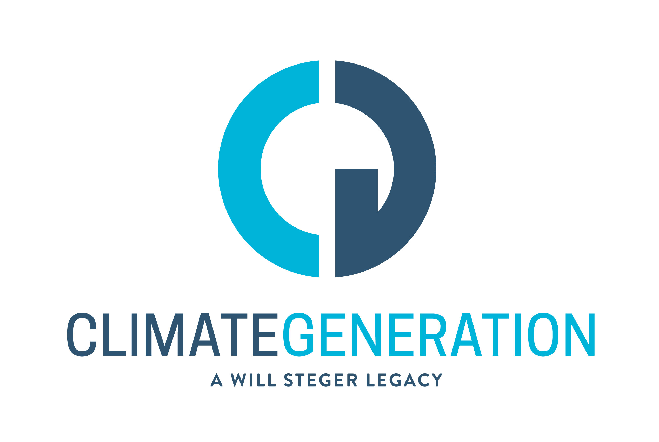

Will Steger Foundation is now Climate Generation: A Will Steger Legacy

Minneapolis, Minn. – April 29, 2015 – At 70, famed polar explorer and Minnesota environmentalist Will Steger has seen a lot of change. So it’s fitting that the organization he established, the Will Steger Foundation, has changed its name to Climate Generation: A Will Steger Legacy to reflect both its legacy and evolving mission.

“I’ve been talking with audiences about what we can do to fight climate change for more than 10 years,” says Steger. “During that time I’ve engaged with 1,000 educators, 5,000 young leaders and over 60,000 Minnesotans. We are making a difference, but we need to move with more speed and purpose.”

“That is why we are changing the name of the organization,” says Nicole Rom, executive director of Climate Generation (CG). “The time is now. We believe that climate change will define this generation; this generation has been the first to really experience the effects of climate change and will have the biggest influence on how we address it. Furthermore, we want to emphasize that it is young people who are most impacted by climate change and are among our most powerful advocates.”

The organization’s rebranding effort includes a new logo and website, which is displayed above and is attached to this email. The new name and logo was unveiled at Climate Generation’s annual breakfast for supporters, today (Wednesday, April 29) from 7:30-9 a.m. at the Red Stag Supper Club, 509 First Ave. NE in Minneapolis.

Afterwards, Steger, Rom and other Climate Generation representatives met with educators and student leaders at the Red Stag to discuss its recently launched program Climate Minnesota: Local Stories, Community Solutions. The program’s goal is to communicate about climate change, based on local science, stories, and solutions that encompass the broad range of impacts that Minnesotans are seeing now. The project includes public convenings, educator workshops and a TPT television program.

Here are the dates of the 12 convenings. For more details, please visit www.climateminnesota.org:

Bemidji - April 14, 2015 (Special Guest: Mark Seeley)
Crookston - April 15, 2015 (Special Guest: Mark Seeley)
Burnsville - May 12, 2015 (Special Guest: John Abraham)
Duluth - May 18, 2015 (Special Guest: Mark Seeley)
Owatonna – Sept. 15, 2015 (Special Guest: Mark Seeley)
Mankato Area – Sept. 21, 2015 (Special Guest: Paul Huttner)
Virginia –Sept. 24, 2015 (Special Guest: Will Steger)
Rochester – Oct. 12, 2015 (Special Guest: Paul Huttner)
Brainerd – Nov. 2, 2015 (Special Guest: Mark Seeley)
Detroit Lakes – Nov. 2, 2015 (Special Guest: Mark Seeley)
Minnetonka – Nov. 12, 2015 (Special Guest: Paul Douglas)
Marshall – Jan. tbd, 2016

During the April 29 meeting, speakers also discussed what youth and educators are doing to engage in climate change solutions. They described how youth are working to support a strong Clean Power Plan and an increased Minnesota renewable energy standard, as well as taking action at their high schools, including recycling, composting and education initiatives. And they shared how educators are addressing climate change and energy education in their classrooms with curricula resources and support provided by Climate Generation.

About Climate Generation: A Will Steger Legacy

Established in 2006, Climate Generation: A Will Steger Legacy (CG) educates and empowers people to engage in solutions to climate change. Originally the Will Steger Foundation, Climate Generation was established by famed polar explorer and environmentalist Will Steger, and is based in Minneapolis. CG has been a leading voice for climate change education and instrumental in passing the state’s nation-leading renewable energy legislation, aggressive carbon reduction goals and most recently a solar energy standard. The new website is www.climategen.org.

###

Twitter: @climategenorg Facebook: www.facebook.com/climategen

