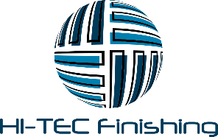

August 27, 2019

Re: Water Gremlin Company and Hi-Tee Finishing

To Whom It May Concern:

Hi-Tec Finishing (“Hi-Tec”) recently entered into a contract with Water Gremlin Company (“Water Gremlin”) in which Hi-Tec agreed to process certain Water Gremlin products using equipment provided to Hi-Tec by Water Gremlin. Hi-Tec became properly permitted for these operations through the State of Wisconsin. When it entered into the contract with Water Gremlin, Hi-Tec was unaware that the chemicals used to process the Water Gremlin products are alleged to be unsafe and unhealthy. Hi-Tec only became aware of this fact on August 26, 2019 after being advised by the local media. In response, Hi-Tec has taken immediate steps to terminate its relationship with Water Gremlin and will not be performing any processing work for Water Gremlin.

Hi-Tec very much values its relationship with the City of Hudson and its residents and apologizes for any concerns this matter has raised.

Sincerely,

Brent LaBrie

Chief Executive Officer
B.L. Business Services LLC
d/b/a Hi-Tee Finishing

