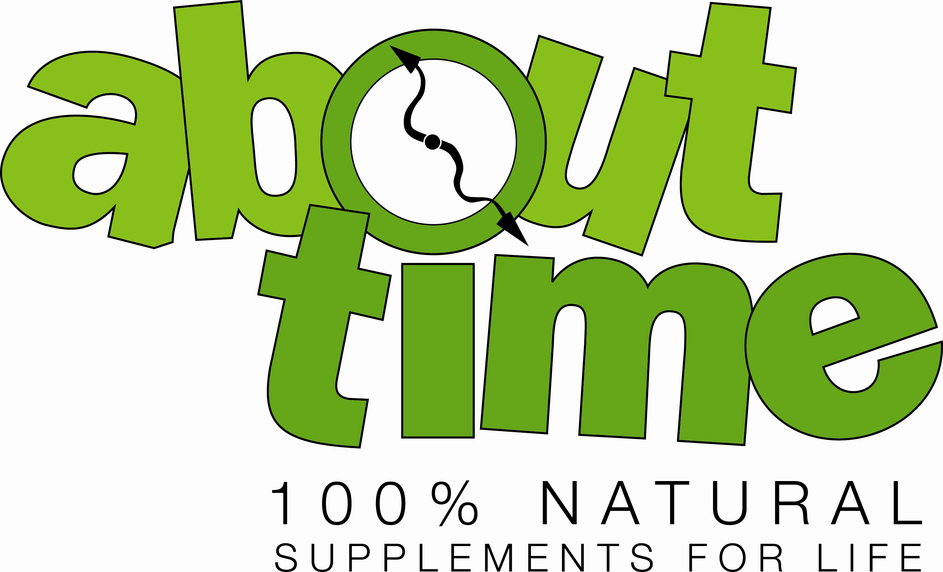

Shakes/Smoothies

Strawminade
4 oz lemonade
4 oz water
1 scoop About Time Strawberry protein
2 small fresh mint leaves
add all ingredients to blender and mix, add 3 to 4 small ice cubes if you want it frozen

Orange Sherbet
4 oz Orange Juice
4 oz water
2 oz unsweetened Almond milk
1 scoop About Time Vanilla protein
lemon zest- 4 strands
lime zest- 4 strands
¼ c shredded carrots
add all ingredients to blender and mix, add 3 to 4 small ice cubes if you want it frozen

Banana Bread
8 oz unsweetened Almond milk
4 oz water
1 scoop About Time Cinnamon Swirl protein
½ small banana
4-6 chopped walnuts
8-10 chopped raisins
add all ingredients to blender and mix

Cappuccino
8 oz cold coffee
4 oz unsweetened Almond milk
1 scoop About Time Chocolate protein
1/3 cup blueberries
2 packets pure via
¼ teaspoon cocoa
dash of cinnamon
add all ingredients to blender and mix, add 3 to 4 small ice cubes if you want it frozen

Pineapple Cheese Cake
8 oz unsweetened Almond milk
4 oz water
1 scoop About Time Birthday Cake protein
2 Tablespoons cottage cheese
1 ½ Tablespoons crushed pineapple
lemon zest- 4 strands
lime zest- 4 strands
add all ingredients to blender and mix, add 3 to 4 small ice cubes if you want it frozen

Sunrise
8 oz unsweetened Almond milk
4 oz water
1 scoop About Time Birthday Cake protein
4 medium strawberries
¼ cup mandarin oranges- drained
1 ½ Tablespoons crushed pineapple
1 Tablespoon dry oatmeal- quick oats
lemon zest- 4 strands
add all ingredients to blender and mix

Green and Greek
8 oz unsweetened Almond milk
4 oz water
1 scoop About Time Birthday Cake protein
½ small banana
¼ ripe avocado- peeled
4 Tablespoons plain Greek yogurt
add all ingredients to blender and mix

Antioxidant
8 oz blueberry pomegranate juice
8 oz water
1 scoop About Time Vanilla protein
18-20 fresh spinach leaves
½ tomato- chopped
add all ingredients to blender and mix

Hawaiian Coconut
8 oz unsweetened Coconut milk
1 scoop About Time Chocolate protein
½ small banana
2 Tablespoons crushed pineapple
2 packets pure via
add all ingredients to blender and mix, add 3 to 4 small ice cubes if you want it frozen

Fruit and Veggie#1
8 oz water
4 oz unsweetened Almond milk
18-20 spinach leaves
1 scoop About Time Birthday Cake protein
¼ cup blueberries
lemon Zest- 4 strands
add all ingredients to blender and mix

Fruit and Veggie #2
8 oz unsweetened Almond milk
4 oz water
18-20 spinach leaves
1 scoop About Time Birthday Cake protein
¼ fresh apple- peeled and chopped
2 tablespoons crushed pineapple
lemon zest- 4 strands
add all ingredients to blender and mix

Sour Patch
6 oz lemonade
2 oz water
1 scoop About Time Strawberry protein
¼ cup blueberries
¼ cup mandarin oranges
2 Tablespoons Greek yogurt
2 tablespoons crushed pineapple
add all ingredients to blender and mix, add 3 to 4 small ice cubes if you want it frozen

Cookies

Chocolate Oatmeal cookies
3 cups quick oats
1 cup peanut butter
¾ cup Agave nectar (light)
3 scoops About Time Vanilla protein
3 scoops About Time Chocoalte protein
6 Tablespoons water
3 teaspoons flax seeds
1 ½ teaspoons cinnamon
¾ teaspoon nutmeg
½ teaspoon salt- optional

Preheat oven to 325 degrees.
Mix all dry ingredients together, add the peanut butter and knead into the dry mix. Add agave nectar and mix. Finally add water and mix. Dough will be stiff. Portion out into 24 balls on a cookie sheet. Flatten with the palm of your hand or the bottom of a clean glass. Cookies will rise slightly but will not spread. Bake for 7 minutes

each cookie:
calories-140
fat-6 g
carbs- 10 g
protein- 10g

Oatmeal Raisin Pecan cookies
2 cups quick oats
1 cup Almond flour
1 cup Agave nectar (light)
8 scoops About Time Vanilla protein
1 cup raisins
1 cup pecans- chopped
½ cup + 2 Tablespoons peanut butter
2 eggs
1 Tablespoon vanilla extract
1 Tablespoon cinnamon
1 teaspoon baking powder
1 teaspoon all spice
½ teaspoon nutmeg

Preheat oven to 325 degrees.
Mix all dry ingredients together, in a seperate bowl mix together the agave nectar, vanilla extract and eggs. Add the peanut butter and knead into the dry mix. Add the Agave nectar vanilla and eggs to the dough and mix well.Portion out into 30 balls on cookie sheets. Flatten with the palm of your hand or the bottom of a clean glass. Bake for 13-15 minutes.

Each cookie
calories-125
fat- 4.75 g
carbs- 12 g
protein-10 g
fiber- 2 g
sugars- 6 g

Cakes

Lemon Blueberry Almond cake
1 cup quick oats
1/3 cup quick oats- for crumble topping
8 oz cream cheese- (cansubstitute up to 6 oz with yogurt)
½ cup almond slivers
5 scoops About Time Vanilla protein
1 scoops About Time Vanilla protein- for crumble topping
2/3 cup blueberries
2/3 cup milk
5 tablespoons tofu
1/3 cup Agave nectar (light)
1/8 cup Agave nectar (light)- for crumble topping
1 egg
1 Tablespoon flax seed
1 Tablespoon oat bran
¾ teaspoon baking powder
1 Tablespoon lemon extract
¼ teaspoon salt- optional

Preheat oven to 325 degrees.
Mix all dry ingredients together, in a seperate bowl or mixer, cream the cream cheese and add the agave nectar, lemon extract, milk, tofu, and egg. Mix well. Add the the dry ingredients and fold until blended. Fold in the blueberries. Pour into a deep cookie sheet or 9x13 cake pan sprayed and lined with wax paper. This will allow the wax paper to not move. Spray the top of wax paper also.

Mix the remaining 1/3 cup of quick oats &1 scoop of About Time protein powder. Sprinkle over the top of the mix. Drizzle the remaining 1/3 cup of agave nectar on top of batter. Bake 16 to20 minutesor until center just begins to bounce back. Do not over cook.

Strawberry Short Cake
1 cup quick oats
1/3 cup quick oats- for crumble topping
8 oz cream cheese- (cansubstitute up to 6 oz with yogurt)
½ cup pepitos (pumpkin seeds)
5 scoops About Time Vanilla protein
1 scoops About Time Vanilla protein- for crumble topping
2/3 cup strawberries- frozen thawed and patted dry
2/3 cup milk
5 tablespoons tofu
1/3 cup Agave nectar (light)
1/8 cup Agave nectar (light)- for crumble topping
1 egg
1 Tablespoon flax seed
1 Tablespoon oat bran
¾ teaspoon baking powder
1 Tablespoon Vanilla extract
¼ teaspoon salt- optional

Preheat oven to 325 degrees.
Mix all dry ingredients together, in a seperate bowl or mixer, cream the cream cheese and add the agave nectar, Vanilla extract, milk, tofu, and egg. Mix well. Add the the dry ingredients and fold until blended. Top with berries.Pour into a deep cookie sheet or 9x13 cake pan sprayed and lined with wax paper.This will allow the wax paper to not move. Spray the top of wax paper also.

Mix the remaining 1/3 cup of quick oats &1 scoop of About Time protein powder. Sprinkle over the top of the mix. Drizzle the remaining 1/3 cup of agave nectar on top of batter. Bake 16to20 minutes or until center just begins to bounce back. Do not over cook.

Pecan and Pear
1 cup quick oats
1/3 cup quick oats- for crumble topping
8 oz cream cheese- (cansubstitute up to 6 oz with yogurt)
½ cup pecans
5 scoops About Time Vanilla protein
1 scoops About Time Vanilla protein- for crumble topping
2 fresh pears, cored, sliced thin and slightly sauted with cinnamon
2/3 cup milk
5 tablespoons tofu
1/3 cup Agave nectar (light)
1/8 cup Agave nectar (light)- for crumble topping
1 egg
1 Tablespoon flax seed
1 Tablespoon oat bran
¾ teaspoon baking powder
1 Tablespoon Vanilla extract
1 Tablespoon vegetable oil- to saute pears
½ Tablespoon Cinnamon
1/8 teaspoon cinnamon- to cook with pears
¼ teaspoon salt- optional

Preheat oven to 325 degrees.
Mix all dry ingredients together, in a seperate bowl or mixer, cream the cream cheese and add the agave nectar, vanilla extract, milk, tofu, and egg. Mix well. Add the the dry ingredients and fold until blended. Top with pear slices.Pour into a deep cookie sheet or 9x13 cake pan sprayed and lined with wax paper.This will allow the wax paper to not move. Spray the top of wax paper also.

Mix the remaining 1/3 cup of quick oats &1 scoop of About Time protein powder. Sprinkle over the top of the mix. Drizzle the remaining 1/3 cup of agave nectar on top of batter. Bake 16to20minutesor until center just begins to bounce back. Do not over cook.

Zucchini Cake
1 1/4 cup quick oats
8 oz plain yogurt
½ cup walnuts
6 scoops About Time Vanilla protein
2 cups shredded zucchini
2/3 cup milk
5 tablespoons tofu
1/3 cup Agave nectar (light)
2 eggs
1 Tablespoon flax seed
1 Tablespoon oat bran
1 Tablespoon cinnamon
¾ teaspoon baking powder
¾ Tablespoon vanilla extract
1 teaspoon nutmeg
¾ teaspoon allspice
¼ teaspoon cloves
¼ teaspoon salt- optional

Preheat oven to 325 degrees.
Mix all dry ingredients together, in a seperate bowl or mixer, cream the yogurt and add the agave nectar, vanilla extract, milk, tofu, and eggs. Mix well. Add the the dry ingredients and fold until blended. Fold in zucchini.Pour into a deep cookie sheet or 9x13 cake pan sprayed and lined with wax paper.This will allow the wax paper to not move. Spray the top of wax paper also.

Bake 16to20 minutes or until center just begins to bounce back. Do not over cook.

