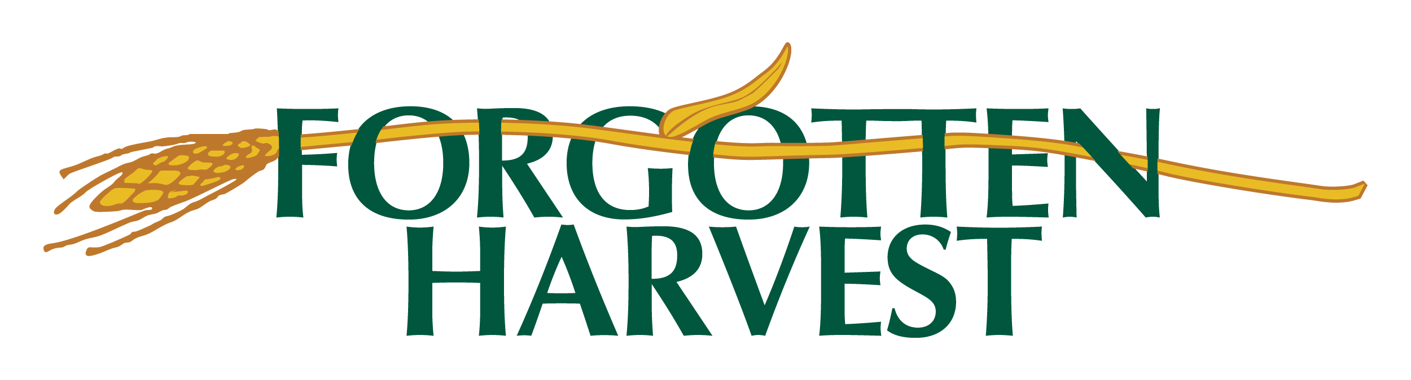

Top Ten Most Wanted Food Drive Items for Forgotten Harvest
1. Fresh shelf stable produce items
2. Canned Meat, Fish & Soups
3. Canned Ready to Eat Meals
4. Canned Vegetables & Tomato Products
5. Peanut Butter (plastic container)
6. Iron Rich Cereal (45% or more of daily value)
7. 100% Fruit Juice (48 oz. or less plastic bottles)
8. Canned Fruit (in juice)
9. Dry Beans (any type)
10. Enriched Rice or Pasta

Examples of fresh shelf stable produce items:
Potatoes, onions, apples, sweet potato, rutabagas, and squash

