**Suggested Bike Routes to the Ford Arts, Beats & Eats Festival**

**General Suggestions**

* Stay off of the sidewalks
* Stay off of Eleven Mile Road
* Stay off of Main Street as motorists coming from the side streets cannot see a cyclist approaching quickly on the sidewalks and are likely to enter the street without stopping.

1. From the North, west of Main:

Take Maxwell south, to Sherman east, to Lafayette south. You can go south on Lafayette until you get to the bike corral just south of Lincoln or at Eleven Mile you can walk your bike to the corral on Washington, just south of Eleven Mile.

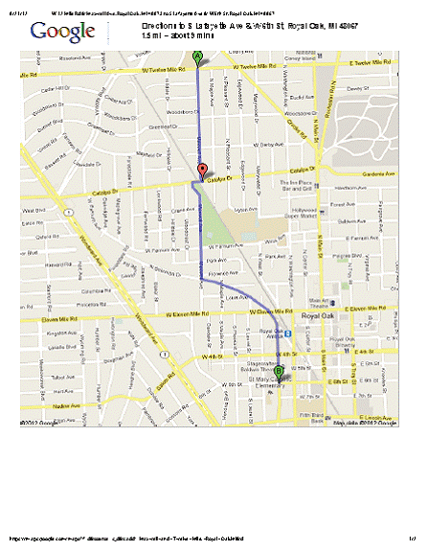

1. From the North, east of Main:

Take Troy St. south to Hudson, then go west on Hudson to Lafayette, north to the bike corrals.

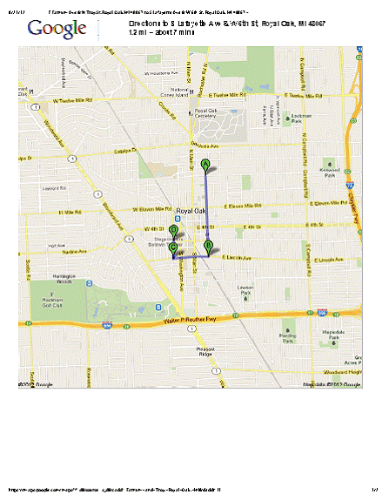

1. From the West: Catalpa east, to Maxwell South, then follow directions in #1.

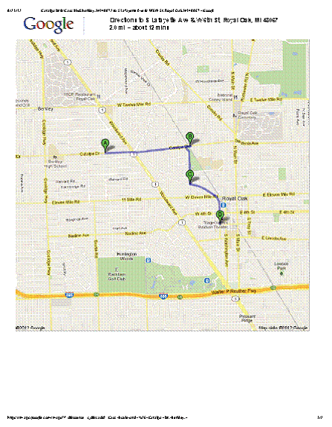

1. From the East, south of Downtown Royal Oak: Lincoln east to Troy Street west to Hudson south to Lafayette north to the bike corrals

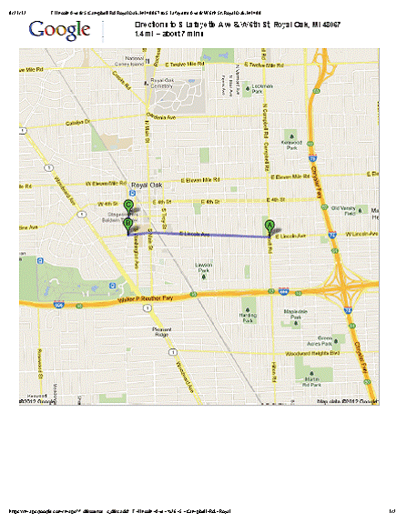

1. From the East, north of Downtown Royal Oak: Take Gardenia west, cross Main (becomes Catalpa); south on Maxwell & follow instructions in #1.

