SLEEP DEPRIVATION IN AIR TRAFFIC CONTROL COMMUNITIES

by

Elizabeth Ann Barcus

A Graduate Capstone Project
Submitted to ERAU Worldwide
In Partial Fulfillment of the Requirements of the Degree of
Master of Science in Aviation/Aerospace Operations

Embry-Riddle Aeronautical University
Worldwide
Louisville, KY Center
January, 2011
SLEEP DEPRIVATION IN AIR TRAFFIC CONTROL COMMUNITIES

by

Elizabeth Ann Barcus

This Graduate Capstone Project
was prepared under the direction of the candidate’s Project Review Committee Member.
Dr. Angela Bower, Adjunct Assistant Professor, Worldwide Campus,
and the candidate’s Project Review Committee Chair,
Dr. Lawrence Fahey, Adjunct Associate Professor, Worldwide Campus, and has been
approved by the Project Review Committee. It was submitted
to the Worldwide Campus in partial fulfillment of
The requirements for the degree of
Master of Science in Aviation/Aerospace Operations

PROJECT REVIEW COMMITTEE:

____________________________________
Angela Bower, Ed.D.
Committee Member

____________________________________
Lawrence Fahey, Ph.D.
Committee Chair

ii
ACKNOWLEDGEMENTS

I want to extend heartfelt gratitude to all of my brothers and sisters of NATCA that participated in the survey. Without you, there would be no paper. Additionally, thank you to Jeff Gilde, Victor Santore and Phil Barbarello for paving the way, as well as my fellow controllers at SDF and LOU who so kindheartedly became my guinea pigs. In solidarity…..
Thanks to my board: Dr. Fahey and Dr. Bower. And to Dr. Gaddy, you were there in the beginning.
Also thanks to my husband Paul, you are my rock!
Dedicated to Mom. Miss you so…..

iii
ABSTRACT

Researcher: Elizabeth Ann Barcus

Title: Sleep Deprivation in Air Traffic Controller Communities

Institution: Embry-Riddle Aeronautical University

Degree: Master of Science in Aviation/Aerospace Operations

Year: 2011

As an air traffic controller with over 11 years of experience, I have observed first hand, co-workers attempting to perform duties while extremely fatigued. Many determinants may have a role in the controllers’ fatigue; their particular sleep habits or health, to name a few. What is also represented, is the fact that present governing directives in no way allow efficient rest time between shifts for controllers to operate safely, with cognizance to current studies on sleep loss and the effects of fatigue. Through a short World Wide Web survey, made available to randomly selected air traffic controllers, I am going to identify that controllers are working fatigued every day. Additionally, with respect to current research on sleep deprivation and fatigue identify that these operations are inherently dangerous to aviation.

iv
TABLE OF CONTENTS
Page

PROJECT REVIEW COMMITTEE ii
ACKNOWLEDGEMENTS iii
ABSTRACT iv
LIST OF FIGURES viii
Chapter
I INTRODUCTION 1
Background of the Problem 1
Researcher’s Work Setting and Role 1
Statement of the Problem 2
Limitations 2
Assumptions 3
Definition of Terms 3
Acronyms 3
II REVIEW OF RELEVANT LITERATURE AND RESEARCH 5
The Human Body and Sleep 5
Shift Work 6
Fatigue 7
Policies 7
Summary 8
Statement of the Hypothesis 9
v
III RESEARCH METHODOLOGY
Research Model 10
Survey Population 10
Source of Data 11
The Data Collection Devices 11
Pilot Test 12
Instrument Pretest 12
Distribution Method 12
Instrument Reliability 13
Instrument Validity 13
Procedures 14
Treatment of Data 16
IV RESULTS 17
V DISCUSSION 25
VI CONCLUSION 26
VII RECOMMENDATIONS 27
REFERENCES 28
APPENDIXES
A BIBLIOGRAPHY 31
B PROPOSAL SCHEDULE 32
C DATA COLLECTION DEVICE 33
D PERMISSION TO CONDUCT RESEARCH 36
vi
E GRAPH OF FAA REGIONS 38

vii
LIST OF FIGURES
Figure Page
1 Results of question 1 broken down into number of responses 18
2 Results of question 2 broken down into number of responses 19
3 Results of question 3 broken down into number of responses 20
4 Results of question 4 broken down into number of responses 21
5 Results of question 5 broken down into number of responses 22
6 Results of question 6 broken down into number of responses 23
7 Results of question 7 broken down into number of responses 24
8 Map of FAA regions 38

viii
1
CHAPTER I
INTRODUCTION
Background of the Problem
Every human being has felt the effects of sleep deprivation. According to the National Sleep Foundation, “$35 Billion dollars is lost yearly in America in productivity, sick leave, medical expense, property and environmental damage” (Bratman, 2006, pg 2). This phenomenal amount is due to sleep deprivation, which is a condition that effects no one more than the shift worker. Those people in the health care industry, military, and public safety workers all feel the pressure of sleep deprivation (Bratman, 2006).
The aviation community has felt the squeeze of having to work sleep deprived. With the birth of the 24-hour airports, therein shift work was introduced. In this instance, however; there is an inherent safety issue. Lives could be lost if a pilot or air traffic controller is too fatigued to perform their work safely due to lack of sleep.
This paper will attempt to take a closer look at current policies on sleep deprivation in the Air Traffic Control community and to identify if policies in place reflect current studies of sleep and fatigue.
Researchers Work Setting and Role
As a former Naval Air Traffic Controller of over 7 years and a controller for the Federal Aviation Administration (FAA) for over 4 years, I have first-hand experience of shift work and the fatigue felt by my colleagues and I. Additionally, I have formally studied sleep and its effects for 7 years, throughout my tenure in an aviation undergraduate and graduate program.
2
Statement of the Problem
With aircraft operations up and still growing, it is apparent that the need for more intense safety standards is evident. The study of sleep deprivation and the effects of fatigue is its own science today, and these findings are inherent to safe air travel by aviators in every department.
Significance of the Problem
With increasing amount of enplanements in every sector of aviation, sleep deprived workers will cause additional losses that will effect everyone. The Canada Department of Transportation reported an overwhelming 21% of all aircraft incidents are fatigue related to some degree (Marcel, 2000). This is a phenomenal amount and reflects the United States own findings. Data from fatigue and sleep deprivation studies should play a major role in the writing of future policies.
Limitations
It would be desirable to ask every air traffic controller whether they think that their watch schedule allows them a proper amount of sleep per night. Since this is not a feasible task, a random sampling of the population will give a good example of most controllers’ opinions.

3
Assumptions
Although it is evident that policy makers have attempted to introduce protection for air traffic controllers fatigue levels in the past, however; new evidence collected over the last few decades screams for extensive re-writing of policies. There is some difficulty for an introduction of new policies due to contractual requirements between the FAA and the FAA controller union, National Air Traffic Controllers Association, (NATCA), a collective bargaining unit. What should remain at the forefront of all negotiations of policies is the safety of our flying public. With the assumption that controllers are indeed working our skies overly fatigued every day, this is a problem needing immediate attention and even faster results.
Definition of Terms
Circadian Rhythm-Occurring in an approximately 24-hour period/cycles (biological activities)
Deprivation-The action of depriving or the state of being deprived
Fatigue-Weariness or exhaustion from labor, exertion, or stress
Acronyms
ARTCC-Air Route Traffic Control Center, (Center)
Controller-Air Traffic Controller
FAA-Federal Aviation Administration
FAR-Federal Aviation Regulations
NATCA-National Air Traffic Controllers Association
NTSB-National Transportation Safety Board
4
Mids-Midnight shifts (Occurs between the hours of 10 p.m. and 6 a.m.)
Tower-Air Traffic Control Tower
TRACON-Terminal Radar Approach Control
VFR-Visual Flight Rules

5
REVIEW OF RELEVANT LITERATURE AND RESEARCH
The Human Body and Sleep
The human body is extremely complex in every aspect. The success of how the body functions are in the rhythms the body uses that have different frequencies and amplitudes. These rhythms are broken into three main categories: ultradian rhythms, circadian rhythms, and infradian rhythms (Costa, 1999). Every body rhythm is important to normal function, but the most studied is circadian rhythm because of the mountainous influence on performance on an everyday basis.
Circadian rhythm is the scientific term for the way the body tells us that it needs to sleep to restore energy. Circadian rhythm may also be deemed a “body clock”, effective over a period of 22.5 to 27 hours by a varying light/dark cycle (Costa, 1999).
When our body doesn’t get the rest it is requesting, sleep deprivation occurs. A groggy feeling, lack of alertness, and a steady decline in performance are some of the factors relating to lack of sleep (Smolensky, 2005). Most people have symptoms of sleep deprivation to some degree, however; no person is effected like the shift worker. Shift work forces people to adapt to unusual work schedules, with the night shift worker the most effected. The night worker must adjust their normal sleep-wake pattern, which in turn forces the body to shift its body rhythm according to the time of the persons shift. Thusly, the circadian rhythm becomes exposed to continuous stress. The circadian rhythm attempts to adjust itself as quickly as possible when it becomes stressed (Costa, 1999). This stress can lead to mental and physical problems including fatigue, digestive

6
problems, and poor mental agility, however; sleep is the main function altered (Buxton, 2000). While these stresses on the body are extremely harmful, many more diseases are likely to follow in the life of a person chronically sleep deprived: depression, cardiovascular diseases including stroke, and heart attack (Bratman, 2006).
Shift Work
Air traffic controllers feel the effects of these symptoms daily. There are many different shift schedules that an air traffic controller may work. One example is a week to week schedule. The controller will work a week of days (typical shift from 6am-2pm), a week of eves (2pm-10pm), and finally a week of mids (10pm-6am). This schedule doesn’t appear to be particularly hard for the body to become adjusted to, but research has reported that the circadian rhythms of workers on the night shift (mids), never adjusts completely and the body tends to desynchronize and never normalizes to night work, even after working this schedule for prolonged periods of time (Marcil, 2000). Some additional research provided results that stated that air traffic controllers working five consecutive night shifts accumulated a sleep dept of more than 10 hours. This was due in part of a low average of daytime sleep and poor sleep quality of daytime sleeping (Marcil, 2000).
It’s not only the night shift that air traffic controllers find a decline in sleep. Another type of schedule controllers may work, is a backwards rotating schedule. This schedule starts the controller on an eve shift on day 1, followed by an eve or day shift. Day 3 will be another eve or day. Day 4 will be a day shift, followed by 8 hours off,

7
with day 5 as the mid that same night. All of these days may be separated by a mere 8 hours, which in that time, the controller is expected to drive home, deal with household duties, rest if possible, drive back to work and be prepared to work another 8 hour shift. Studies have reported that controllers on a rotating shift report a steady decline in the amount of sleep due to the quick turn-around (Marcil, 2000).
It seems that any schedule that an air traffic controller works has the potential to allow for a degree of sleep debt. Some inhibitors to fatigue for controllers also come from their own personal habits and behavioral characteristics such as exercise, balanced diet and good time management strategies (Marcil, 2000).
Fatigue
While each person’s ability to manage sleep deprivation and fatigue on the job differ enormously, what must remain in constant are the policies in effect by administration to protect the controller from fatigue related incidents and accidents. When the Canadian Department of Transportation reported that a staggering 21% of all aviation incidents and accidents have some degree of fatigue relating to them, this would prove that current policies in effect are largely due for a reconstruction.
Policies
The basic watch schedule and maximum working hour policies differ by each type facility. In a Control Tower, a controller must be “relieved of all duties at least 24 consecutive hours at least once during each 7 consecutive days” (FAR 65, 2006). The FAR also states that an “an operator may not be required to serve for more than 10

8
consecutive hours; or for more than 10 hours during a period of 24 consecutive hours, unless the controller has had a rest period of at least 8 hours at or before the end of 10 hours of duty”.
The policy for a terminal radar facility is as follows: “the controller may not work more than 10 operational hours in a shift. Hours worked before a shift, whether operational or not, will count as operational” (FAA 7210.3, 2006). Additionally, the FAA publication 7210.3 expresses that “all work beyond 10 hours must be nonoperational, have at least an 8 hour break from the time work ends to the start of any subsequent shift and an off-duty period of at least 12 hours following a midnight shift, (is defined by any shift that the majority of hours worked are between 10 p.m. and 8 a.m.)”. Also, the FAA 7210.3 states “a controller may work no more than 6 shifts without taking a regular day off”.
Summary
Clearly the rules in place are set to protect the controller and the aviator from fatigue related incidents and accidents aren’t providing sufficient amount of rest between watches. Every policy for the type facility has provided an 8 hour break for the controller, which is in no way appropriate amount of rest time before another watch. Studies have shown that small periods of sleep deprivation have been known to effect performance and that signals were missed and lapses in performance were recorded following a sleep loss of 2 and a half hours over a two night period (Hawkins, 2001).

9
Statement of Hypothesis
Are policies in place regarding rest periods in the air traffic controller shift schedule conclusive to current studies of fatigue and sleep deprivation? I don’t believe that a controller could get appropriate rest between watches with only an 8 hour break. The average American shift worker averages only 5 hours of sleep a night (Medical Editorial Board, 2006). Is this because they choose to sleep only 5 hours, or because they are not given enough time off to allow for more sleep?
Another recent survey showed that people that get less than 6 hours of sleep a night can effect coordination, reaction time and judgment (CNN, 2000). Do we really want our nation’s controllers operating with such deficiencies?

10
CHAPTER III
RESEARCH METHODOLOGY
A Quantitative Research Approach
A quantitative research approach will be taken to view what air traffic controllers actually feel about their shift work and their feelings of fatigue while on duty. Particular attention will be paid to how many hours of sleep the controller will get at night on a weekly average, and what reasons they think their sleep is disturbed. The survey will be non-racial or gender stating.
Survey Population
The survey will be made available on the website www.surveymonkey.com to 3 randomly selected FAA air traffic facilities in the 9 separate FAA regions throughout the United States, (excluding Alaskan, it is a very small population and will not have a random selection available). The three separate facilities will be 1-VFR Tower, 1-TRACON and 1-Center. For this study, a combined tower and TRACON will be considered a TRACON, and a combined TRACON and ARTCC will be considered an ARTCC.
In August of 2006, NATCA.org reported “14,305 air traffic controllers that work for the FAA”. Based upon data taken from the publication “A Plan For The Future 2007-2016”, retrieved from (FAA.org, 2007), the average number of controllers working at an ARTCC are 290.48. Additionally, there are an average of 20.22 controllers at a TRACON and 7.14 at a Tower (FAA.org, 2007). By calculating the average number of controllers that will be invited to participate in this survey, 3 of each type facilities per 10
11
regions, then expecting 20% participation, an estimated 580 controllers are expected to take the survey, which equals over 4% of the population.
Sources of Data
The results from the survey will be analyzed quantitatively using statistical calculations to provide confidence levels. Qualitative research on shift worker fatigue and governing ATC policies will also be utilized to support the hypothesis.
The Data Collection Device
The survey will contain 8 questions pertaining to controller sleep patterns and fatigue. The controller will also be asked to approximate their level of fatigue felt per week using a 1-10 scale, with 1 being not fatigued and 10 being very fatigued. Additionally, the survey sample will be asked if they are familiar with current guidelines and policies regarding their maximum working hours and time off, followed by whether they think the guidelines reflect current studies of fatigue and sleep deprivation. They will be asked how often they feel fatigued at work, if they do feel fatigued-check some of the reasons they feel fatigued, (common disruptions of sleep were named, e.g.: shift-work schedule, insomnia, and relationship problems at home). They will be asked whether they feel their average amount of sleep per week allocates a safe, efficient and attentive working shift. The survey will have a comment box at the end also available.

12
Pilot Study
A pilot test was conducted at 2 FAA facilities, Louisville International Airport-Standiford Field (SDF) a combined tower/TRACON, and Louisville Bowman Airport
(LOU), a VFR tower. 50 surveys were provided to the controllers and over 20 days, 34 responses were collected. 68% of the population surveyed responded.
Instrument Pretest
From the 34 responses received from the pilot study, it appeared that the questions were clear, concise and valid to the problem, however; there was one question that asked if the controller felt that more time off between shifts would help feelings of fatigue. I found this question to be slightly leading in that it is making an assumption that the controller feels fatigue and this may not be accurate. The responses from the pilot test will be included in the results from the GCP, excluding the previously mentioned question.
Distribution Method
Distribution of the Pilot Study was by hand and a drop-box was provided for finished surveys. For the formal study, a website will be made available for the randomly selected facilities. The survey will be the only screen made available for viewing. It will be titled, briefly describe the importance of the study, inform of anonymity and brief instruction. There will also be a small blurb on the NATCA’s official website, www.NATCA.org, describing my background and the role of the study.

13
Instrument Reliability
Based on responses received from the Pilot Study, the instrument appeared to be a reliable tool for measuring controllers’ fatigue. With the absence of any questions where all of the responders answered exactly the same, reliability is assumed. No statistical
analysis was performed on the results, as the responses will be added to the formal study.
Instrument Validity
From the data collected during the pilot study, the questions asked were all pertinent to the fatigue problems that controllers face daily. The first 2 questions ask if the subject is aware of the guidelines regarding the maximum hours they can work and if they think the guidelines reflect current studies of fatigue and sleep deprivation. These 2 questions were pertinent to get an idea of the subjects’ knowledge of FAA/NATCA bargaining unit regulations and their base knowledge of previous fatigue and sleep deprivation studies. The next 2 questions ask how often fatigue is felt and to assign their fatigue a number from a numbered scale. This will give an idea as to how the subject themselves rate how tired they are when they are at work. Questions 5 asks the subject to (circle on pilot and check for the GRP), identify some of the reasons that may be causing their fatigue while at work. Choices include but are not limited to: relationship problems at home or work, nerves, insomnia and not enough time off between shifts to get adequate sleep. This will give a better understanding of what may be causing a fatigue issue with the controller. The reasons may be entirely unrelated to ATC regulations. On
the pilot test, question 6 asked “Do you think more time off between shifts would help
your feelings of fatigue at work”? I am going to remove this question, as it is
14
too leading. Question 5 asks if “not enough time off between shifts to get adequate sleep”, if highlighted, it would be an answer for question 6.
Question 7 asks how many hours that the subject gets per day, on average. This is important to better understand what sleep they are getting even with the reasons that may be disruptive. Lastly, Question 8 asks whether they feel that their average sleep per day is enough to get them through a safe, efficient and attentive shift at work and whether they feel they should not be plugged in if those feelings were affirmative. These questions are very important, because they evaluate whether the subjects feel that coming to work without proper rest is unsafe. Past studies show this is unsafe and similar to being intoxicated.
Procedures
After years of research identifying that fatigue in an Air Traffic Control work-center is very prevalent, I wanted to ask the controllers what they think of current policies on fatigue and how they would rate their fatigue.
When I left the Navy and was hired by the FAA, I discovered that agencies have different policies regarding shift hours, and that the FAA has to come to an agreement with the controllers’ union NATCA regarding their shift schedule. Also, no 2 facilities are exactly the same. For instance, Louisville International Standiford Field (SDF) is the World Hub of UPS Airlines. UPS flies their cargo during mids, thus SDF has a higher
concentration of controllers on a midnight shift, unlike other airports, when this would be the slowest time. With that in mind, making random selections of each type facility from

15
each of the FAA regions was deemed the best course of action to get controller viewpoints from all over the U.S.
From the fatigue research, a hypothesis was stated and the plan of who the survey would question was decided, followed by what the survey questions would be.
When pondering what questions to ask on the survey, I looked back at my 11 years of controlling experience and tried to concentrate on how I was effected by rotating shifts and the demand of everyday life. Once the survey questions were chosen, the decision to test them on local controllers in the Louisville, KY area was made. I sent an e-mail to Louisville International Standiford Field (SDF) and Louisville Bowman Field (LOU) facility NATCA Representatives Jeff Gilde and Miguel Velasquez an e-mail explaining my background and the background of my research, why I was doing the study and what the Pilot Test survey would look like, to get permission from NATCA to do the survey. The Southern Region NATCA Vice President Victor Santore approved of the survey at the 2 facilities and the surveys were handed out to the controllers. After gathering the finished surveys and evaluating the validity and reliability, and subsequent changes made, the website hosting the GRP survey began to take shape and is still under construction.
I have gained approval from the NATCA Public Relations President Phil Barbarello to begin the survey of selected facilities for the GRP. Again, SDF NATCA
Representative Jeff Gilde aided me in getting the approval by forwarding information about this project to the appropriate parties.

16
Treatment of Data
From the estimation that 4% of the entire FAA controller population will have taken this survey, a 95% confidence level of the results is desired. Statistical analysis including trends will be applied to the results from the survey. Easy to read charts of the results will be included.

17
CHAPTER IV
RESULTS
During the months that the survey was open to participants, there was concern raised over one of the 8 questions. Question 8 stated: Do you ever feel that you shouldn’t be plugged in because you feel unsafe, inefficient or inattentive while on duty because of your lack of sleep? I believe concern was raised over a liability issue of a NATCA personnel knowingly working when they feel unsafe. The question was removed from the survey. It was deducted that there would be enough data and trends from the 7 other questions to gather quality data from the survey.
Alaska Region was also added to the random selection process. Because of the Alaskan day/night cycle, controllers in those facilities may be more at risk for fatigue; hence they were added to the selection.
The survey itself was made available to randomly selected facilities for a full 60 days. Approximately 3200 controllers (including Alaska), were invited to participate in the survey and of the estimated 580 controllers expected to participate in the survey, (before Alaska was added), 321 took the survey, equaling approximately 2.25% of the population and 10% response rate.

18
Although there were slightly less participants than anticipated, there is enough data from the 321 controllers to see some definitive trends in their answers.

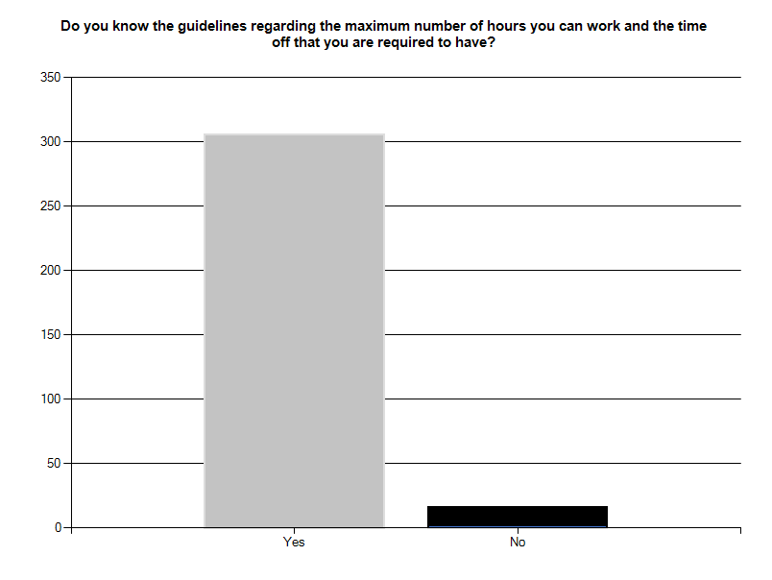
Figure 1. Results of question 1 broken down into number of responses. From Sleep Deprivation in ATC Communities, by Elizabeth Barcus, 2010, www.surveymonkey.com.

The majority of respondents is aware of the maximum working hours and required time off.

19
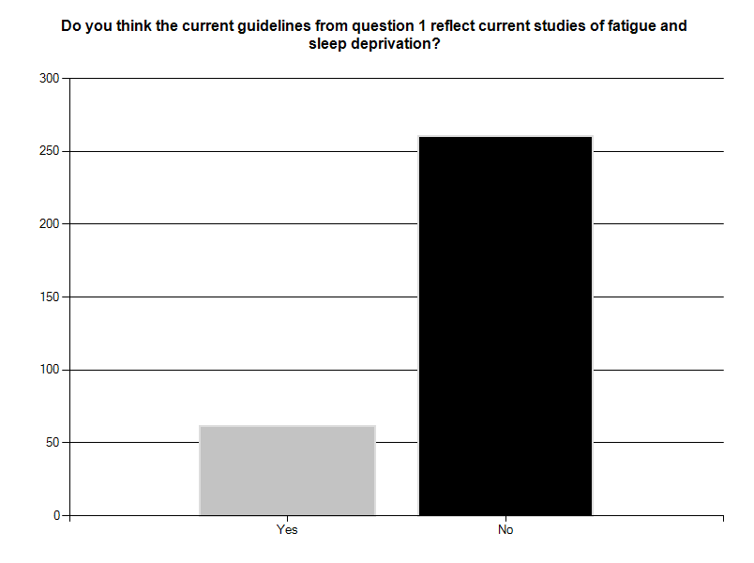
Figure 2. Results of question 2 broken down into number of responses. From Sleep Deprivation in ATC Communities, by Elizabeth Barcus, 2010, www.surveymonkey.com.

The respondents here are saying they are well read on fatigue studies and find current FAA guidelines lacking in respect to the findings of those studies.

20
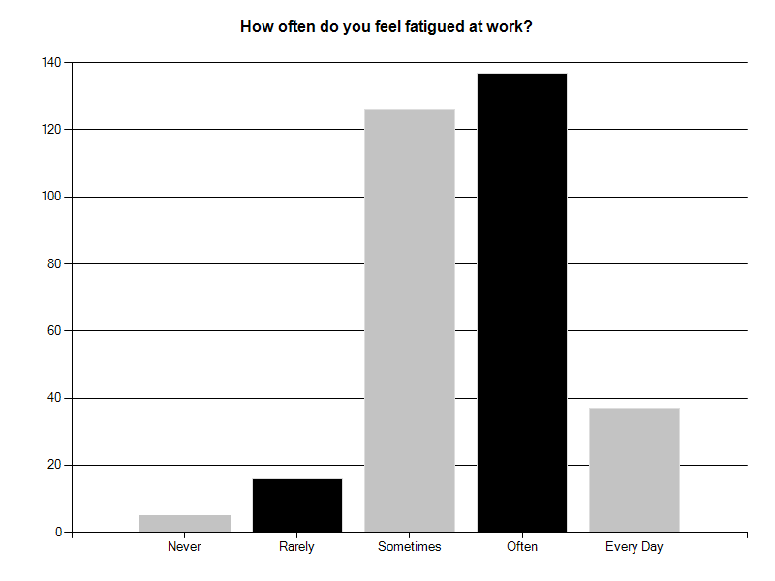
Figure 3. Results of question 3 broken down into number of responses. From Sleep Deprivation in ATC Communities, by Elizabeth Barcus, 2010, www.surveymonkey.com.

From the graph of the results of question 3, it is very evident that most respondents view themselves as sometimes and often fatigued during their work day.

21
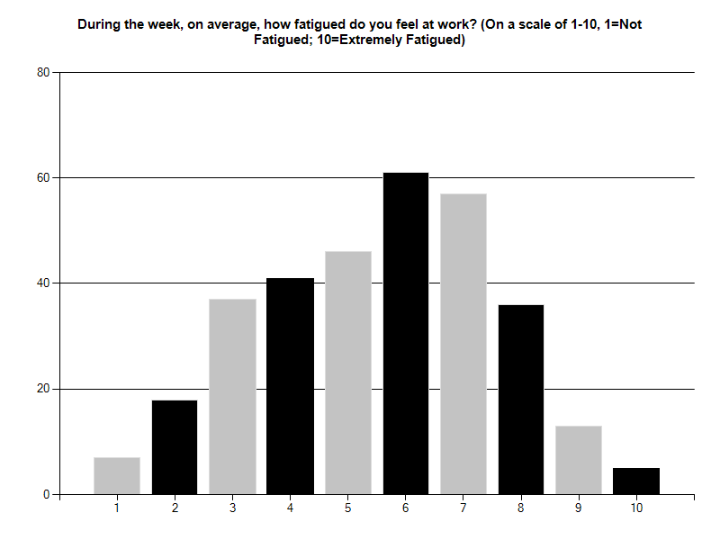
Figure 4. Results of question 4 broken down into number of responses. From Sleep Deprivation in ATC Communities, by Elizabeth Barcus, 2010, www.surveymonkey.com.

Very few controllers felt no fatigue and extremely fatigued during their work-week, as evidenced by the graph. The average controller feels somewhat fatigued during their work-week.

22
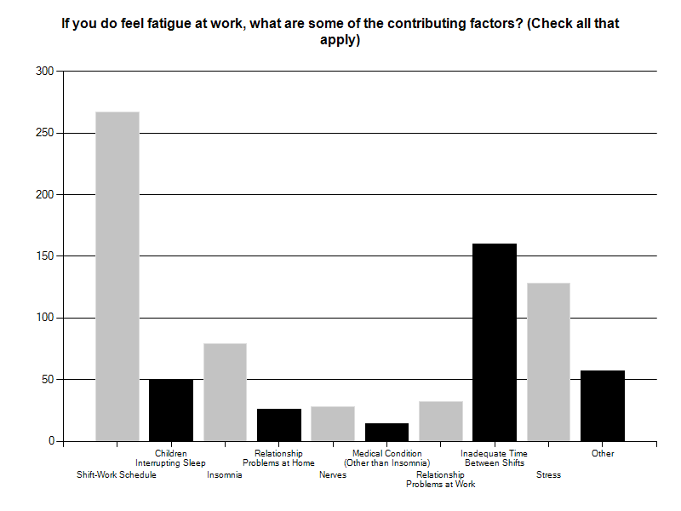 Figure 5. Results of question 5 broken down into number of responses. From Sleep Deprivation in ATC Communities, by Elizabeth Barcus, 2010, www.surveymonkey.com.

From the results of this question, over 2/3 of controllers that felt fatigue at work is due to their shift-work schedule, and half of all respondents chose inadequate time between shifts.

23
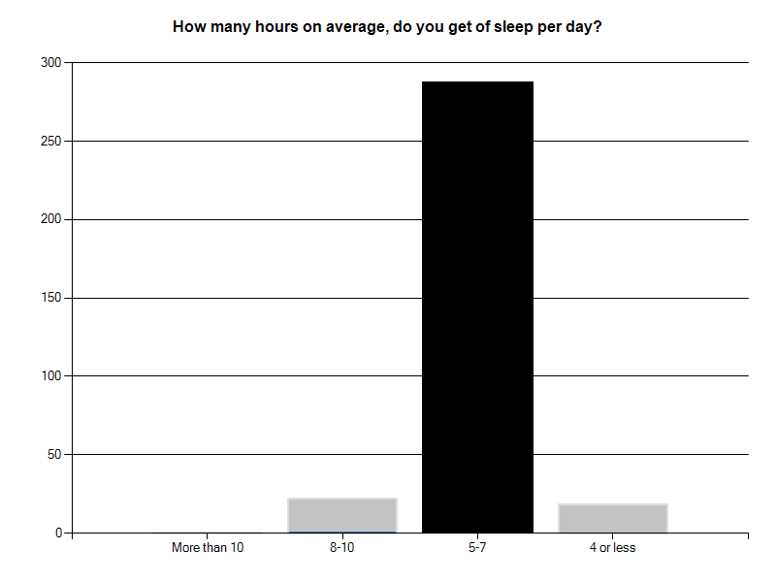
Figure 6. Results of question 6 broken down into number of responses. From Sleep Deprivation in ATC Communities, by Elizabeth Barcus, 2010, www.surveymonkey.com.

As evidenced by the graph, most controllers get between 5-7 hours of sleep per day. With respect to current shift-work guidelines, many shifts have only 8 hours between them and it leaves little time for more sleep.

24
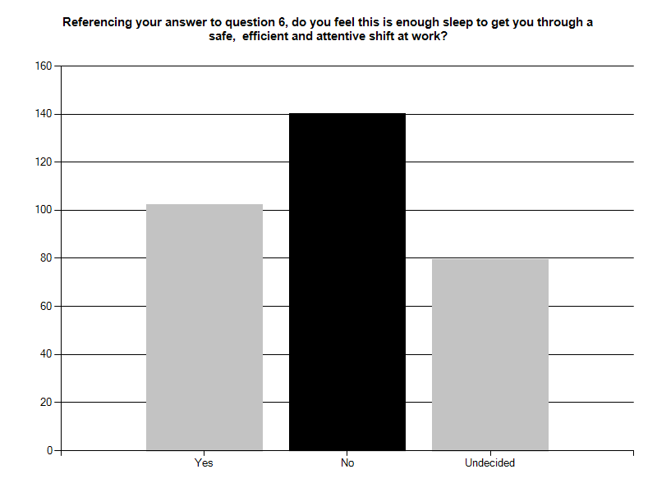
Figure 7. Results of question 7 broken down into number of responses. From Sleep Deprivation in ATC Communities, by Elizabeth Barcus, 2010, www.surveymonkey.com.

From the selections for this question, I believe it is unclear whether controllers feel that yes, their 5-7 hours of sleep are enough to get through a safe, efficient and attentive shift at work, or whether they do not. I do believe that it is a warning flag that approximately 2/3 of respondents felt that it was not enough sleep or they were undecided.

25
CHAPTER V
DISCUSSION
This survey tells the story that controllers are feeling fatigue every day. They believe there are many reasons for that fatigue, but most controllers feel that their shift-work schedule is a contributable factor of the fatigue. There are hundreds of studies regarding sleep deprivation and its effects, however; rules and guidelines are not changing with the findings.
The National Transportation Safety Board (NTSB) has listed fatigue on its most wanted list for the past 2 decades (NTSB, 2010). Additionally, in a letter to the FAA, NTSB chairman Mark Rosenker (2007) wrote “There is clear and compelling evidence that controllers are sometimes operating while fatigued because of their work schedule”, and that “fatigue has contributed to errors”.
It is no easy feat to elicit change. Things have been this way for years, it is what we do. Air Traffic Controllers, the FAA, NATCA, and the NTSB, we all know our working hours, shift work and our lifestyles contribute to inherently dangerous situations, but nothing is taking place to change it. I believe I have said change more often than not throughout this paper. Change is what HAS to happen to provide safer skies for the flying public.

26
CHAPTER VI
CONCLUSIONS
With regards to the current study and its predecessors, I conclude that controllers feel fatigue every day due to the way the shifts are scheduled. As long as controller shifts are unable to adhere to the “body clock”, fatigue will also remain.
Additionally, controllers often work fatigued. The fatigue that controllers feel coincides with the shift work schedule.
Lastly, fatigue is a threat to the aviation community and contributes to unsafe skies.

27
CHAPTER VII
RECOMMENDATIONS
Based on the results of this survey and supporting literature, I recommend that an additional study should be conducted to determine the cost and advisability of scheduling controllers an absolute minimum of 10 hours rest between shifts.
A definitive study should be conducted to determine the benefit of “power naps” during breaks scheduled during working hours.

28
REFERENCES
Barcus, E. (2010). Sleep Deprivation in ATC Communities. Survey Monkey,
http://www.surveymonkey.com/sleepdeprivationatccommunities
Bratman, S. (2006). Sleep: Are You Getting Enough?. New York University Medical
Center, from http://www.med.nyu.edu/patientcare/patients/library/article.html
Buxton, R., Drummond, S., Stricker, J., & Wong, E., (2000). Brain Activity is Visibly
Altered During Sleep Deprivation, from http://health.ucsd.edu
CNN official website. (2000). Sleep Deprivation as Bad as Alcohol, Study Suggests.
Retrieved May 15, 2005, from http://archives.cnn.com/2000/HEALTH/09/20/sleep.deprivation/index.html
Costa, G. (1999). Handbook of aviation human factors. Mahwah, NJ: Lawrence Erlbaum
Associates.
Federal Aviation Administration online document, A Plan for the Future 2007-2016,
(2007, March). Retrieved August 25, 2010, from http://www.employees.faa.gov/org/linebusiness/ato/about/media/CWFP_032007_1up.pdf
Federal Aviation Administration publication, Federal Aviation Regulations part 65,
(2006, August 7). Retrieved September 2, 2006, from http://ecfr.gpoaccess.gov/cgi/t/textidx?c=ecfr&sid=71a8625b8532627abce16584c7aa

29
Federal Aviation Administration publication, 7210.3 Facility Operation and
Administration. Chapters 2-5-1 and 2-6-7, (2006, May 3). Retrieved September 4,
2006, from http://www.faa.gov/ATpubs/FAC/CH2/s0205.html
Federal Aviation Administration Employee official website, FAA Regions and Centers
Map. (2010, December). Retrieved December 21, 2010, from
https://employees.faa.gov/
Hawkins, F., & Orlady, H. (Eds.). (2001). Human Factors in Flight. Burlington, VT:
Ashgate Publishing Company.
Marcil, I., &Vincent, A. (2000). Fatigue in Air Traffic Controllers: Literature Review.
Transport Canada Air Navigation Services and Airspace, from http://www.tc.gc.ca/tdc/projects/air/h/9333/htm
Medical Editorial Board of Sleep Deprivation. (2006). Retrieved August 27, 2006, from
http://www.sleep-deprivation.com/
National Air Traffic Controller Association official website, Air Traffic Control by the
Numbers, (2006, August). Retrieved August 24, 2010, from http://www.natca.org/mediacenter
National Transportation Safety Board official website, Most Wanted Transportation
Safety Improvements. (2010, February). Retrieved December 28, 2010, from
http://www.ntsb.gov/recs/mostwanted/aviation_reduce_acc_inc_humanfatig
Rosenker, M. (2007). Testimony Before the Committee on Transportation and
Infrastructure Subcommittee on Aviation. Retrieved December 27,
2010, from http://www.ntsb.gov/speeches/rosenker/mvr070606.htm
30
Smolensky, K. (2005). Sleep Disorders Research Advisory Board Meeting Minutes.
National Center on Sleep Disorders, Heart, Lung, and Blood Institute, from http://www.nhlbi.nih.gov

31
APPENDIX A
BIBLIOGRAPHY
Barcus, E. (2005). Sleep Deprivation in the United States Navy. 3-7

32
APPENDIX B
PROPOSAL SCHEDULE

Date | Subject | Anticipated Timeframe
7/15/2010 | Begin Research, Gain Approval
 | from Mentor-Boardmembers
7/22/2010 | Pilot Survey Sent | 3 weeks
8/15/2010 | Begin to Build Website
9/15/2010 | Proposal Submitted/GCP Started
9/22/2010 | Send Letters
 | to Random Selected Facilities
9/25/2010 | Have Website Completed and
 | Operational
9/25/2010 | Committee Meeting | 1 hour
11/8/2010 | Begin Analysis of Results from
 | Survey | 3 weeks
11/15/2010 | Finish Statistical Analysis
12/5/2010 | Committee Meeting-Final | 1 hour
1/25/2010 | Finish Paper-Turn in

33
APPENDIX C
DATA COLLECTION DEVICE
QUESTIONNAIRE FOR MEASURING AIR TRAFFIC CONTROLLERS FATIGUE AT WORK
Thank you for completing this questionnaire. It is important that you answer as honestly as possible. Your responses will be anonymous and will be used to further our expanding knowledge of the fatigue that air traffic controllers like you, deal with at work.
Please circle your responses for all questions
1. Do you know the guidelines regarding the maximum number of hours you can work and the time off you are required to have?
YES NO
2. Do you think the current guidelines from question 1 reflect current studies of fatigue and sleep deprivation?
YES NO
The next questions deal with the fatigue you feel while on duty.

34
3. How often do you feel fatigued at work? Please circle your answer
NEVER
RARELY
SOMETIMES
OFTEN
EVERY DAY

Please use the numbered scale and circle your number to give an approximation of the amount of fatigue you feel.
4. On a weekly average, how fatigued do you feel at work?
NOT FATIGUED FATIGUED EXTREMELY FATIGUED
1 2 3 4 5 6 7 8 9 10
5. If you do feel fatigue at work, circle all of the reasons below that may apply to you:
SHIFT-WORK SCHEDULE
CHILDREN KEEP YOU AWAKE WHEN ATTEMPTING TO SLEEP
INSOMNIA
RELATIONSHIP PROBLEMS AT HOME

35
NERVES
MEDICAL CONDITION OTHER THAN INSOMNIA
RELATIONSHIP PROBLEMS AT WORK
NOT ENOUGH TIME OFF BETWEEN SHIFTS TO GET ADEQUATE SLEEP
STRESS
OTHER
6. How many hours on average, do you get of sleep a day?
8-10
5-7
4 or less
Please reference your answer from question 6 for your answer to question 7 and 8.
7. Do you feel this is enough sleep to get you through a safe, efficient and attentive shift at work?
YES NO UNDECIDED
8. Do you ever feel that you shouldn’t be plugged in because you feel unsafe, inefficient or inattentive while on duty because of your lack of sleep?
YES NO UNDECIDED
36
APPENDIX D
PERMSSION TO CONDUCT RESEARCH
This is cleaned-up e-mail/forwards for permission to conduct the study from NATCA.
Hello Jeff,
I noticed that the fatigue paper on the NASA study was removed. Is that study over with now? Why I ask is that I almost have the website built for my actual project sampling and I was hoping to get your assistance in getting the approval from the union to go ahead with it.
What I am trying to do:
Through random sampling, select 1 Center, 1 TRACON and 1 VFR Tower (FAA ONLY), from each region, (Excluding Alaskan because they are so small). I then would like to send a letter or email to the NATCA Region Pres and the Facility Rep explaining my background, what the project is all about, and attach the website info to the letter and give the dates that it will be open for participation. I am working on some sort of password specific way of entering the survey, perhaps by region. I then would either like to get an email spam list of the selected facilities union members so I can email them my background, what the survey is all about, and the website info. Either that, or their facrep can spam it to them, whichever. I would also like to post a short paragraph explaining my work on the NATCA website about the survey and the background of the study.
I am anticipating having the website accessible for at least 45 days. It will remain only 9

37
questions, mostly (Check the box that best applies to you), and should take no more than 5 minutes.
Your guidance and emails on my behalf are greatly appreciated. I will definitely not forget you and my NATCA family in my acknowledgements in the paper.
Thanks,
Liz Barcus
Victor,
This is the same member that did the study at our place. Let me know if she can do this or if you need to talk to her about it.
Jeff Gilde
Facrep SDF

On Aug 20, 2010, at 7:53 AM, Victor Santore wrote:
Phil,
This is the one that wanted to do the fatigue study for a class. Now that ours is over, any problem with it?
Victor Santore
NATCA Southern Region Vice President

No problem
Phil Barbarello
From: Phil Barbarello <nearvp@natca.com>
Date: August 20, 2010 8:33:09 AM EDT

38
APPENDIX E
MAP OF FAA REGIONS
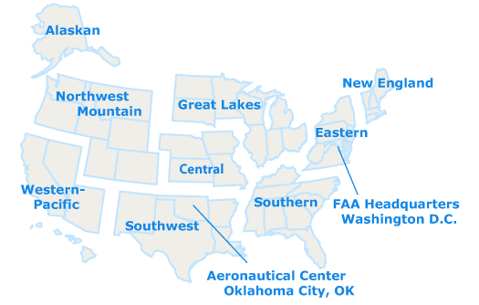
Figure 8. Map of FAA regions. From FAA Employee Homepage, by the Federal Aviation Administration, 2010, Washington, DC:FAA. http://www.employees.faa.gov/

