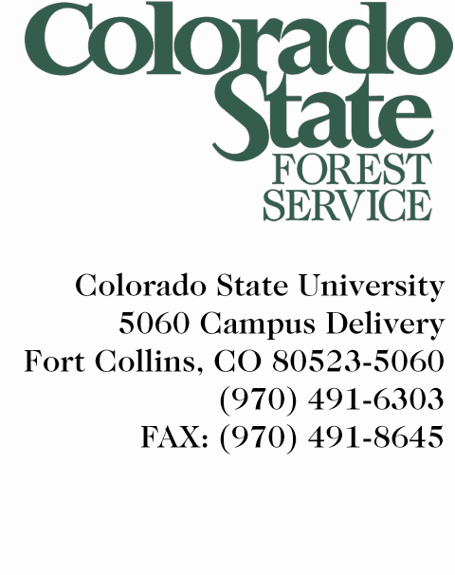

March 28, 2012

Contact for Reporters: Ryan Lockwood , Colorado State Forest Service, (970)491-8970, ryan.lockwood@colostate.edu

Statement from Joe Duda, Deputy State Forester, regarding prior prescribed burn in Lower North Fork (Duda will participate in the scheduled 4pm briefing at the Lower North Fork Fire incident command.)

Preliminary reports indicate that on the fourth day of mop-up operations after a prescribed burn, extremely strong wind appears to have reignited the fire by fanning embers and blowing them into an unburned area outside the containment line. Crews patrolling the area immediately began fighting the fire.

Last Monday (3/19), Colorado State Forest Service initiated a controlled burn on Denver Water Board property. The 50-acre prescribed burn was part of ongoing fuels management activities in the Lower North Fork area as part of a service agreement with Denver Water. On Monday, March 19, crews completed a containment line around the fire area. The actual prescribed fire was carried out and completed on Thursday, with mop-up operations beginning on Friday.

On Monday afternoon (3/26), the fourth day after the burn, a patrol crew reported windy conditions, but no smoke or fire activity along the fire perimeter as they circled the burn area several times. The crew reported a sudden, significant increase in wind and then reported seeing blowing embers carried across the containment line, over a road, and into unburned fuels. The crew immediately requested additional resources and began aggressively fighting the fire.

One of the primary roles of the Colorado State Forest Service is to help keep forests healthy and reduce the threat of catastrophic wildfires through fuel reduction. Prescribed fires are a well established tool in this effort, with many measures in place to make this tool as safe as possible. This is heartbreaking, and we are sorry: despite the best efforts of the Colorado State Forest Service to prevent this very kind of tragic wildfire, we now join Colorado in hoping for the safety of those fighting a large fire, and mourning the loss of life and property.

As the Jefferson County Sheriff's Office further investigates the cause of the current wildfire, Governor John Hickenlooper and Colorado State Forest Service have also asked for an independent panel to conduct a review of the prescribed burn. Work is underway to assemble that independent panel and members will be identified in the near future. In the meantime, the Governor has suspended the use of prescribed burns by state agencies on state land until the review is complete.

Conducting a prescribed burn involves a considerable amount of planning, research and oversight by fire professionals who carefully consider current and future weather forecasts, fuel conditions, and other factors before initiating a burn.
On preliminary review CSFS officials say fire crews followed all procedures and safety protocols in conducting the prescribed burn.

We want to express our deepest sympathy to those who have lost loved ones and those who have lost property, and we hope for the safety of crews as they continue to fight the fire.
###

