Robert C. White
Chief of Police
* APPROVED FOR PUBLIC DISTRIBUTION *

01-10-2013

You can remain anonymous and earn up to
TWO THOUSAND DOLLARS ($2,000)

CAN YOU HELP SOLVE THESE CRIMES?
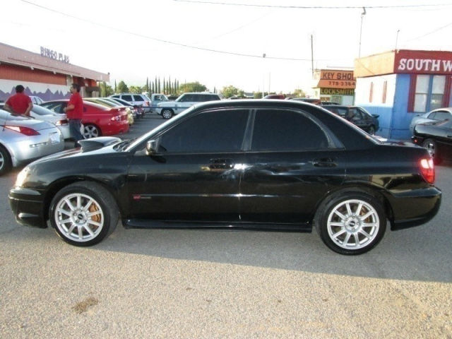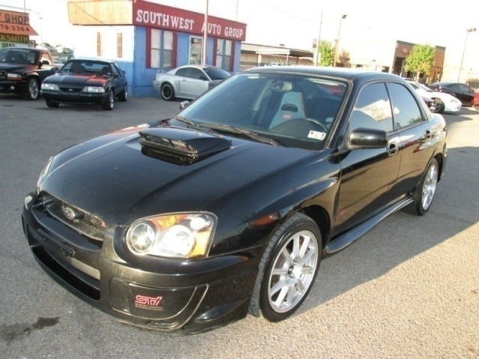
Photos are an example of the vehicle of interest. Not the actual vehicle.

On January 10, 2013, at approximately 9:05 p.m. a dark colored 2004-2005 Subaru Impreza WRX struck a pedestrian at Federal Blvd. and Florida Avenue. The vehicle left the scene at a high rate of speed south bound on Federal Blvd. without contacting police or stopping to assist the pedestrian. The vehicle may have sustained driver’s front end body damage and it will be missing the driver’s side view mirror. The pedestrian was listed in critical condition with numerous internal injuries and fractures.
CASE #2013-16017

Call Crime Stoppers
720-913-STOP (7867)
Text to: 274637 (CRIMES) then title DMCS & enter your message.
Crime Stoppers collects information on unsolved crimes or individuals wanted by the police.
Callers can remain anonymous. The tip line is answered 24 hours a day - 7 days a week

