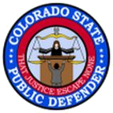
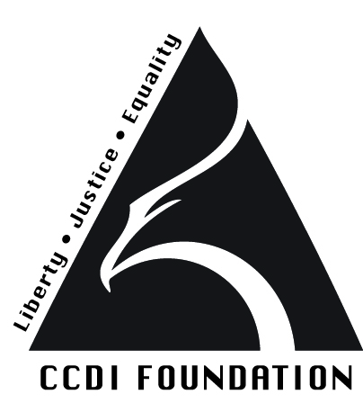
The Colorado Criminal Defense Institute
and the
Colorado State Public Defender’s Office
proudly announce
THE COLORADO COLLATERAL RELIEF PROJECT
Starting September 2015, the Colorado Criminal Defense Institute, in partnership with the Office of the Colorado State Public Defender, will offer free collateral relief legal clinics, funded by the Colorado Justice Assistance Grant (JAG) Program and the Denver Foundation. The clinics will provide legal assistance to former offenders who need relief from the negative impacts of a criminal arrest or conviction.
Eligible cases include: sealing of arrest or conviction records, requests for juvenile expungement, petitions for sex offender de-registration (both juveniles and adults), and securing of judicial orders of collateral relief.
The clinics will be offered around Colorado starting in September 2015 at various locations, mostly at local State Public Defender’s Offices.
No appointments are necessary. All clinics will be walk-in, staffed by legal assistants and others who will conduct the initial screening with follow up assignment to a pro bono attorney. Any clinic can be attended.
For further information, please visit http://pdweb.coloradodefenders.us or http://www.ccdinstitute.org. To talk to someone directly, please contact Maureen Cain, Project Director at 303-758-2454 or maureencain@aol.com.
Dates and locations of the clinics are as follows:
Denver Clinic - Saturday, September 12, 2015, 10 a.m. - 2 p.m.
Public Defender’s Office, 1560 Broadway, #300, Denver, CO 80202

Colorado Springs Clinic -Saturday, October 3, 2015, 10 a.m. - 2 p.m.
Public Defender’s Office, 19 N. Tejon St, Suite 105, Colorado Springs, CO 80903

Arapahoe County Clinic- Saturday, October 10, 2015, 10 a.m. - 2 p.m.
Public Defender’s Office, 12350 East Arapahoe Road, Suite A, Centennial, CO 80112

Pueblo Clinic - Saturday, October 31, 2015, 10 a.m. – 2 p.m.
Public Defender’s Office, Union Depot, 132 West "B" Street, #200, Pueblo, CO 81003

Brighton Clinic - Saturday, November 14, 2015, 10 a.m. - 2 p.m.
Public Defender’s Office 4710 East Bromley Lane, Brighton, CO 80601

Fort Collins Clinic- Saturday, November 21, 2015, 10 a.m. - 2 p.m.
1 Old Town Square, #300, Fort Collins, CO 80524

Golden Clinic - Saturday, December 12, 2015, 10 a.m. - 2 p.m.
Public Defender’s Office, 560 Golden Ridge Road, #100, Golden, CO 80401

Greeley Clinic -Saturday, January 16, 2016, 10 a.m. - 2 p.m.
Public Defender’s Office, 822 7th St., Suite 300, Greeley, CO 80631

Douglas County Clinic - Saturday, January 30, 2016, 10 a.m. - 2 p.m.
Public Defender’s Office, Elk Crossing Business Center, 1161 South Perry Street Suite 200, Castle Rock, CO 80104

Boulder Clinic - Saturday, February 13, 2016, 10 a.m. - 2 p.m.
Public Defender’s Office, 2555 55th Street Suite. D-200, Boulder, CO 80301

Denver Clinic - Saturday, February 27, 2016 from 10 a.m. - 2 p.m.
Public Defender’s Office, 1560 Broadway, Suite 300, Denver, CO 80202

Sterling Clinic - Saturday, March 12, 2016 from 10 a.m. - 2 p.m.
Public Defender’s Office, 214 S. 3rd Street, Sterling, CO 80751

Steamboat Springs Clinic - Saturday, March 26, 2016 from 10 a.m. - 2 p.m.
Public Defender’s Office, 1955 Bridge Lane, Suite 2100, Steamboat Springs, CO 80487

Summit County Clinic - Saturday, April 16, 2016, 10 a.m. - 2 p.m.
Public Defender’s Office, 114 Village Place, #101, Dillon, CO 80435

Aurora Clinic - Saturday, April 23, 2016, 10 a.m. - 2 p.m.
Aurora Strong Resilience Center, 1298 Peoria Street, Aurora, CO 80011

Glenwood Springs Clinic - Saturday, May 21, 2016, 9 a.m. - 11 a.m.
Public Defender’s Office, 311-1/2 8th Street, Glenwood Springs, CO 81601
PLEASE NOTE TIME CHANGE.

Grand Junction Clinic- Saturday, May 21, 2016 from 2 p.m. - 5 p.m.
Public Defender’s Office, 114 North Spruce St., Suite 300, Grand Junction, Colorado 81501
PLEASE NOTE TIME CHANGE.

Additional dates to be determined for:
La Junta, Alamosa, Durango, and Salida.
Check website for updates.

