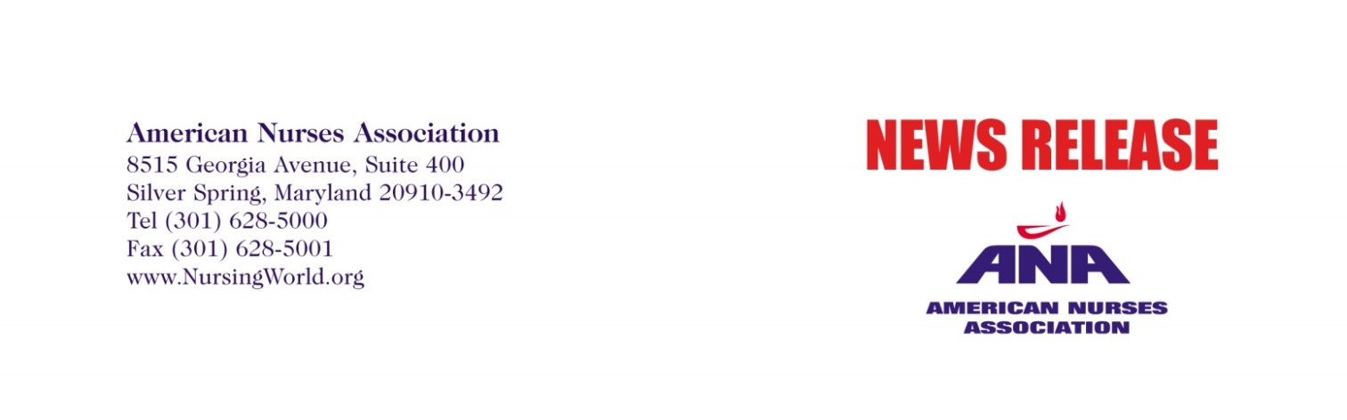
FOR IMMEDIATE RELEASE  September 16, 2015 | CONTACT: | Jemarion Jones, 301-628-5198  jemarion.jones@ana.org  Adam Sachs, 301-628-5034  adam.sachs@ana.org
Statement:
ANA President Pamela F. Cipriano, PhD, RN, NEA-BC, FAAN,
Responds to Comments on ABC’s “The View”

SILVER SPRING, MD – Each and every day, the nation’s 3.4 million registered nurses provide expert, high-quality and compassionate care, as well as dedicated leadership from the bedside to the boardroom. One in every 100 Americans is a registered nurse. We are the frontline caregivers, 24 hours, 7 days a week, who are with individuals from birth, throughout their lifespan and at the end of life. We care for patients, their families and communities. Nurses have a professional, ethical obligation to their patients, and are committed to transforming the health care system to achieve better health outcomes at reduced cost.

That’s why it was disturbing when Joy Behar, co-host of “The View,” used her national platform and influence to mock Miss America contestant Kelley Johnson for wearing a “doctor’s stethoscope” while performing a dramatic monologue about her experience as a registered nurse during the pageant’s talent competition, as if Johnson were wearing a costume.

Nurses don’t wear costumes; they save lives.

That’s why the response to our social media campaign #NursesShareYourStethoscopes has been so overwhelming.

Nurses use stethoscopes and other tools to assess patients and use this information to coordinate the appropriate level of care with physicians and other members of a patient’s health care team.

For the past 13 years, nurses have held the top spot as the public’s most honest and ethical profession in America in an annual Gallup poll, and with good reason. As the largest group of health care professionals, registered nurses protect the public health, provide high-quality, compassionate care, and advocate for patients and their families.

We are pleased that Behar apologized on the show this morning, and think this is a great opportunity for those in the media to highlight the important, lifesaving role of nurses and to show them the respect they deserve.
# # #
ANA is the only full-service professional organization representing the interests of the nation's 3.4 million registered nurses through its constituent and state nurses associations and its organizational affiliates. ANA advances the nursing profession by fostering high standards of nursing practice, promoting the rights of nurses in the workplace, projecting a positive and realistic view of nursing, and by lobbying the Congress and regulatory agencies on health care issues affecting nurses and the public. Please visit www.nursingworld.org for more information.

